**Mapping Global Cities: Understanding the Metropolitan Drivers of Global Growth and Prosperity**

**I. Introduction**

The global economy was unable to regain its pre-crisis growth trend in 2016. Three months after the United Kingdom’s exit from a still-stagnant European Union and two months ahead of the presidential election in the United States, residents and leaders in advanced economies are responding to a decade of insufficiently inclusive economic growth.[1] At the same time, the investment-led model that has propelled China’s economy forward, and the commodities-driven model that has done the same in Latin America, appears to be running up against diminishing returns.[2]

Amid these uncertainties, new questions naturally emerge about how and where the next round of durable economic growth will occur. In terms of “the how,” the developed world has long relied upon productivity-advancing ideas, knowledge, and global connectivity to spur rising living standards.[3] Major emerging markets, as they have grown wealthier and can no longer rely on the forces of economic convergence alone to propel growth, are now increasingly reliant on a similar path to prosperity.[4]

“The where” within these nations will continue to be major cities and metropolitan areas, which concentrate the fundamental factors needed to create competitive environments and generate growth. The global economy and cities are inextricably linked. Cities are essential to the global economy—they are the locus for economic growth and development. And the global economy is essential to cities—tapping global demand for locally-produced goods and services is how they grow and prosper. Three megatrends are distinctly positioning cities as the world’s competitive economic units while simultaneously redefining what it takes for them to excel in today’s economy:

* **Urbanization**, quite simply, has placed cities at the vanguard of global economic growth. Today’s markets crave the knowledge exchange, dense labor pools, and shared inputs that cities provide.[5] Thus, worldwide industrialization has coincided with worldwide urbanization.[6]
* **Globalization**, despite recent slowdowns in global goods trade, has intensified when measured at its broadest—flows of goods, services, capital, people, and data—and will continue apace.[7] Cities must maintain competitive *traded clusters* that generate exports and attract foreign investment, and connect locally made products and services to the global marketplace through *physical and virtual* *infrastructure*.
* **Technological change** will continue to disrupt industries and labor markets. Cities must endow their workforce with the *skills* needed to complement new technologies and the supportive environments for *innovation*.

The pervasiveness of these trends has integrated cities into a world system through which they both *collaborate* via trade and investment and *compete* to attract mobile firms, workers, and capital. In this way, all cities are “global cities.” Market integration has forced city leaders to examine their economic function within an international lens, understand their most potent tradable specializations, and then strengthen those traded industries by investing and stewarding local innovation, workforce, and infrastructure assets, all in service of growth that is robust, enduring, and broadly shared.[8] This aspiration is neither preordained nor easy. Achieving it requires a clear-eyed focus to define, build, and maintain a realistic global competitiveness strategy, acknowledging that all cities are must think globally but not necessarily in the same way.

This report introduces a new typology of global cities by mapping how the core factors of metropolitan competitiveness—tradable clusters, innovation, talent, and infrastructure—are distributed across the world’s largest city-regions, and what that dispersal means for the future of global growth and prosperity. It is structured as follows. In Part II, we further explore the three global forces of urbanization, globalization, and technological change, and how together they are demanding city-regions focus on four core competitiveness factors—traded clusters, innovation, talent, and infrastructure. Part III outlines our data and clustering methodology. Part IV introduces a new typology of global cities. Grouped into seven metropolitan clusters, the distinct competitive positions of the world’s largest metro economies become sharper, as do the peers metropolitan areas can look to for common solutions and investments to enhance economic growth. Finally, Part V explores the future investments, policies, and strategies required for each grouping of metro areas. Within the cluster framework, we explore the priorities for action going forward.

1. **Global Megatrends and Cities**

Three significant forces—urbanization, global integration, and technological change—continue to drastically reshape the global economy. While typically examined at the global or national scale, these trends are also uniquely local. All three are coming to ground in the world’s major urban economies. To be sure, these are not the only major shifts to which cities must respond. Political polarization at the national level, the inexorable impact of climate change, and rising mass migration are all presenting new challenges for urban areas. Notwithstanding the importance of these social, environmental and political megatrends, we focus on these three forces, specifically, because they are distinctly positioning cities as the world’s competitive economic units while simultaneously redefining what it takes for them to excel in today’s economy.

**Urbanization**

The world is becoming more urban, placing cities squarely at the center of global economic development. The share of global population in metropolitan areas has grown from 29 percent in 1950 to well over half today, and is predicted to reach 66 percent by mid-century.[9]

History indicates that urbanization both accompanies and facilitates economic transition from agriculture to manufacturing and services, activities that tend to demand clusters of labor and capital, as well as proximity to other firms that cities provide. Urbanization and industrialization, therefore, tend to occur in concert. These twin forces, which revolutionized Europe and North America in the late 19th century and early 20th century, have now touched Asia, Latin America, and parts of Sub-Saharan Africa over the past several decades. Millions of rural residents each week flock to urban regions in the Global South in search of the living standards that new production and services jobs provide. Since 2010 annual urban populations have grown fastest in Africa (3.55 percent) and Asia (2.50 percent), greatly exceeding the pace of urban growth in North America (1.04 percent) and especially Europe (0.33 percent).[10]

The pressures and opportunities accompanying urbanization will be felt most intensely and directly in the Global South, but the knock-on effects will be worldwide. Urbanization in emerging economies has resulted in a much greater number of urban areas in which firms and workers can thrive. As a result, along with their growing human footprint, metro areas are flexing even greater economic muscle on the world stage. Overall, urban areas now make up half the world’s population and produce roughly 80 percent of its total output.[11]

Urbanization, however, comes with risks if it is unmanaged. Rapid population influxes in the megacities of Africa, Latin America, and Southeast Asia have overwhelmed basic housing, transportation, energy, water, and sewage infrastructure.[12] If the negative externalities of congestion, insecurity, and health risks overwhelm the positive agglomeration externalities that cities provide, countries run the risk of urbanizing without growth.[13]

**Globalization**

Global integration has been a defining trend of the post-war era, fueled by revolutions in transportation, urbanization and the rapid rise of emerging markets, the globalization of finance, and the advent of multinational-led global value chains. While globalization is not a new phenomenon, recent research has found that, when measured at its broadest, it is intensifying.[14] The volume of goods, services, and investments between countries increased from $5 trillion in 1990 to $30 trillion in 2014, or from 24 percent to 39 percent of global GDP.[15]

These connections matter. More internationally connected countries can expect to increase GDP growth from flows by up to 40 percent more than less connected countries.[16] These findings affirm a wide array of economic literature citing the net benefits of trade and investment. Trade allows metro areas to grow wealthier. Firms selling internationally inject new wealth from abroad that, when spent locally, creates a “multiplier effect” in the regional economy, spurring new jobs, growth, and further tax revenue to be reinvested locally.[17]

Participating in global trade also makes metro economies more productive because firms that generate revenue from outside their local market must provide goods and services faster, better, and cheaper than global competitors. Local companies that embed themselves in global value chains gain access to high-quality inputs, lower overall costs, and as a result become more globally competitive. This process tends to boost productivity and wages.[18] Furthermore, global exchange is how regions with fewer industrial capabilities often obtain the knowledge required to move up the economic ladder, create new jobs, and boost productivity.[19]

Noting these net positives, cities also bear the brunt of the dislocations caused by global integration. For instance, China’s insertion into the global trading system resulted in significant job losses in U.S. labor markets that specialized in manufacturing, and that dislocated workers did not move into new industries.[20] Western policymakers have vastly underestimated the insecurity experienced by many workers and communities as a result of globalization. Recognizing these costs is an important and urgent matter for public policy. But barring adoption of severe isolationist policies, global integration will continue apace, and all cities must respond accordingly.

**Technological Change**

Finally, the information technology revolution, digitization, and labor-saving automation are altering how we communicate, how firms create products and services and deliver them across the globe, and the very nature of work itself.[21]

The scale of these technological changes is significant and the pace of change has been relentless. The McKinsey Global Institute predicts that 12 emerging technologies will generate an annual economic impact of up to $33 trillion by 2025.[22] Our Brookings colleagues argue that many of these technologies will be developed and deployed within a set of 50 advanced industries across manufacturing, services and energy. These industries are “advanced” because they rely on high levels of research and development (R&D) and significant numbers of science, technology, engineering and mathematics (STEM) workers.

Advanced industries matter because they are disproportionately driving productivity growth in an environment where overall productivity growth been lackluster.[23] The average worker in advanced industries is twice as productive as the average worker outside the super-sector, due to their uniquely abilities to productively complement the new technologies and platforms. This productivity differential matters because it allows these workers to earn wages double those of workers outside of advanced industries.[24] Cities that can foment environments in which highly productive firms and workers can thrive enjoy the associated wage benefits.

Risks accompany these high-tech breakthroughs, however. The OECD estimates that about 9 percent of jobs across 21 countries are automatable.[25] Already demonstrated technologies have the potential to automate 45 percent of work activities in the United States.[26] Indicative of their deployment of labor-saving technology, U.S. employment in advanced industries has been flat since 1980, even while its value-added growth has soared. And automation is not simply an advanced world labor market problem. Premature deindustrialization suggests that manufacturing, in particular, will not provide the same on-ramp for lower income countries going forward, with potentially significant economic and political consequences.[27]

Especially as populations age and workforces retire, productivity growth, rather than population growth, will have to do the heavy lifting to maintain overall economic growth.[28] Since technology appears to be such a critical input to worker, firm and industry-level productivity, cities must understand and adopt to its impact.

1. **Data and Methods**

**Defining and Measuring Competitiveness**

These three trends underscore a new economic reality for cities. For starters, rapid urbanization has placed emerging market metro areas alongside their more developed peers as the main sites for economic growth and development. That means understanding global market currents requires an understanding of the economic dynamics playing out in the world’s cities. Alongside urbanization, globalization and technological change are both valuing cities, and challenging them in new ways to deliver prosperity for their residents. The opportunities and pressures of global integration mean that cities must proactively adapt and position workers, industries, and communities for the upsides of global engagement by investing in a competitive traded sector, maintaining infrastructure connectivity, and being open to global flows of capital and talent.[29] Finally, to manage technological change and reap the productivity gains that will improve living standards, cities must cultivate innovation systems, skilled workforces, and digital infrastructure.

Given these factors, this report draws on a five-factor competitiveness framework—tradable clusters, innovation, talent, infrastructure, and governance. Globally competitive traded sectors, innovation ecosystems, and skilled labor are the key drivers of overall productivity, employment creation, and income growth. Enablers support these drivers: well-connected infrastructure and reliable governance, public services, and business environment (see sidebar).[30] Data limitations unfortunately limit our ability to quantitatively measure governance in this report.



**Measuring Competitiveness Factors**

**Tradable Clusters:** Tradable industries are a critical driver of prosperity and competitiveness. These industries are typically anchored by globally engaged firms, which have valuable spillovers for local economies. The traded sector can be measured several ways, including exports and imports and foreign direct investment. We measure tradable industries using data on Greenfield foreign direct investment, which is inextricably bound up with traded industry clusters.[31]

**Innovation:** A region’s innovative capacity and levels of entrepreneurship both have implications for its ability to develop and deploy commercial applications, start new businesses, and maintain industrial competitiveness in the face of disruptive technological change.[32] We measure innovation through the scientific impact of research universities, patenting, and venture capital flows.[33]

**Talent:** Human capital, the stock of knowledge, skills, expertise, and capacities embedded in the labor force, is of critical importance to enhancing productivity, raising incomes, and driving economic growth.[34] We measure talent through the share of population with tertiary education and the share of the population that is foreign-born.

**Infrastructure:** Infrastructure connectivity matters for regional competitiveness because firms rely upon global access, both physically through ports, airports, and logistics systems and digitally through the internet, to bring their products and services to markets outside the region in the most cost-effective manner possible.[35]

Together, these factors add up to a metro area’s competitiveness. This research draws on the Harvard Business School definition of a competitive market as one in which firms can compete successfully in the global economy while supporting high and rising living standards for local households.[36] Competitive regions are, by this definition, supportive environments for both companies and people. Focusing on these fundamentals positions metropolitan economies to compete based on the distinct long-term value their industries and people can provide, and avoids economic strategies that attract firms through “race-to-the-bottom” techniques that compete via one-time tax breaks or depressing wages.

**Selection and Definition of Metropolitan Areas**

We deploy new, standardized metropolitan-level to measure these competitiveness factors for 123 large metro areas. This sample constitutes the largest metropolitan economies in the world in 2015 at purchasing power parity (PPP) rates for which data on these competitiveness factors were available.[37] With a few exceptions, these metro areas all tend to have economies larger than $100 billion in nominal terms. As previous studies have shown, including Brookings’ own Global MetroMonitor and studies by the McKinsey Global Institute and World Bank, global growth is not solely powered by these large metro economies, in fact small and mid-sized cities matter greatly.[38] Data limitations prevent us from analyzing a larger sample of economies on all these competitiveness factors. Given these limitations, we focus on the largest city-regions because they uniquely agglomerate the assets that undergird global competitiveness and growth. They are the main infrastructure connection points to second and third-tier cities. They agglomerate universities, skilled workers, and other innovation assets that yield the positive externalities and knowledge spillovers that generate endogenous growth.[39]

This study uses the general definition of a metropolitan area as an economic region with one or more cities and their surrounding areas, all linked by economic and commuting ties (see Appendix A). These definitions are the same as those used in previous versions of Brookings’ Global MetroMonitor.

**Metropolitan Typology**

To help understand the differentiated metropolitan footprint of economic competitiveness, we develop a metropolitan typology based on regional economic characteristics and competitiveness factors. Classifying and identifying peers allows policymakers and stakeholders to better understand the position of their economies in a globalized context as well as to conduct constructive benchmarking. To select peers we utilized a combination of principal components analysis (PCA), k-means clustering, and agglomerative hierarchical clustering.[40] These commonly used data science techniques allowed us to group metro areas with their closest peers given a set of economic and competitiveness indicators. We used 35 variables in the PCA analysis (see Table 1). For more details, see Appendix A.

**Table 1. Indicators used in the clustering algorithm**

|  |  |  |
| --- | --- | --- |
| **Dimension** | **Indicator** | **Source** |
| ***Economic and Industrial Characteristics*** | Population, 2015 | Oxford Economics, U.S. Census Bureau |
| Gross domestic product, 2015 | Oxford Economics, Moody's Analytics |
| Gross domestic product per capita, 2015 | Oxford Economics, Moody's Analytics, U.S. Census Bureau |
| Output per worker, 2015 | Oxford Economics, Moody's Analytics |
| Industry share of overall output, 2015 | Oxford Economics, Moody's Analytics |
| Industry output per worker, 2015 | Oxford Economics, Moody's Analytics |
| ***Traded Clusters*** | Greenfield foreign direct investment, 2009-2015 | fDi Intelligence data |
| Greenfield foreign direct investment per capita, 2009-2015 |
| Greenfield foreign direct investment jobs created, 2009-2015 |
| ***Innovation*** | Share of total publications in top 10 percent cited papers, 2010-2013 | Centre for Science and Technology Studies (CWTS) and Leiden University data |
| Share of total publications done with industry, 2010-2013 |
| Total patents, 2008-2012 | REGPAT |
| Total patents per capita, 2008-2012 |
| Venture capital investments, millions of dollars per 1,000 inhabitants, 2006-2015 | Pitchbook |
| Venture capital investments, millions of dollars, 2006-2015 |  |
| ***Talent*** | Share of population 15+ with tertiary education, 2014 or latest year available | Oxford Economics, U.S. Census Bureau |
| Foreign-born share of total population, latest year available |
| ***Infrastructure*** | Total aviation passengers, 2014 | SABRE |
| Total aviation passengers per capita, 2014 |
| Average internet download speed, 2015 | Net Index |

1. **Mapping the Economic Assets of Global Cities**
2. **The Aggregate Clout of Large Metro Economies**

The world’s large metropolitan areas are notable in their economic primacy. With about 13 percent of the world’s people, 123 large metro economies generate nearly one-third of global economic output. Nearly all of these metro economies generate more than $100 billion in annual economic output (in nominal terms), led by Tokyo ($1.6 trillion) and New York ($1.5 trillion).[41]

These metros concentrate economic activity because they house the competitiveness assets required to drive global growth. They are important nodes for investment, attracting more than $5.4 trillion in Greenfield foreign direct investment (FDI) since 2009. Asian metro areas have attracted the most FDI since 2009: six of the top ten largest inflows were destined for Asian metro areas, including Singapore, Shanghai, Hong Kong, Beijing, Suzhou, and Chongqing. When controlling for population size, FDI concentrations are still greatest in many of these Asian metros, but smaller metro economies in the United States (Austin and Vancouver), Europe (Birmingham and Barcelona), and Australia (Sydney) also join the top 10.

These metro economies are critical generators of new scientific research and innovation. Together, they account for 44 percent of the world’s most scientifically impactful research universities, generate 65 percent of all patents, and attract 82 percent of all venture capital. A different set of metro economies leads in this regard. The largest patent producing metros are among the largest economies in the world, including Tokyo, Seoul-Incheon, Shenzhen, Osaka, and San Jose. In terms of patents per capita, a smaller set of highly innovative cities rises to the top: San Jose, San Diego, San Francisco, Boston, and Stuttgart. Many of these metro areas are also among the most-educated in the world. San Jose, San Francisco, and Boston join Singapore, London, Washington, and Madrid as the metros with the highest shares of their population with tertiary education.

**Figure 1. Metros Share of Global Total**

These metros also concentrate much of the world’s critical infrastructure. In 2014, airports in these metro areas transported more than 4.9 billion air passengers. The largest metro economies in the world, which house multiple large airports, move the most aviation passengers. New York, London, Shanghai, Los Angeles, Tokyo, Beijing, Chicago and Atlanta had the highest passenger volumes in 2014.

1. **The Seven Types of Global Cities**

This collective economic clout, however, masks the significant variation in which competiveness factors area distributed across 123 of the largest metropolitan economies in the world. San Jose houses some of the most innovative companies in the world and boasts the highest patenting per capita rate in our sample, but ranks 85th in air passenger flows. Similarly, Toronto has the highest concentration of foreign-born inhabitants, representing 50 percent of total population, but ranks 31st when looking at venture capital flows per capita. However, global cities indices typically bundle all these indicators into one composite score or ranking, missing that cities are performing different functions in the global economy based on their competitive endowments.[42]

While each metropolitan economy in our sample possesses a unique trade, innovation, talent, and infrastructure profile, the distribution of these assets reveals a clear typology of places across the world. We used advanced statistical techniques to cluster metro economies based on their size, industrial structure, and competitiveness factors. In some cases, these clusters align to specific regions, like in China or the United States. But just as often the groupings unite metro economies from different parts of the world, showcasing that they share more in common with far-flung counterparts than their regional neighbors.

**Map 1. Seven Metropolitan Clusters**

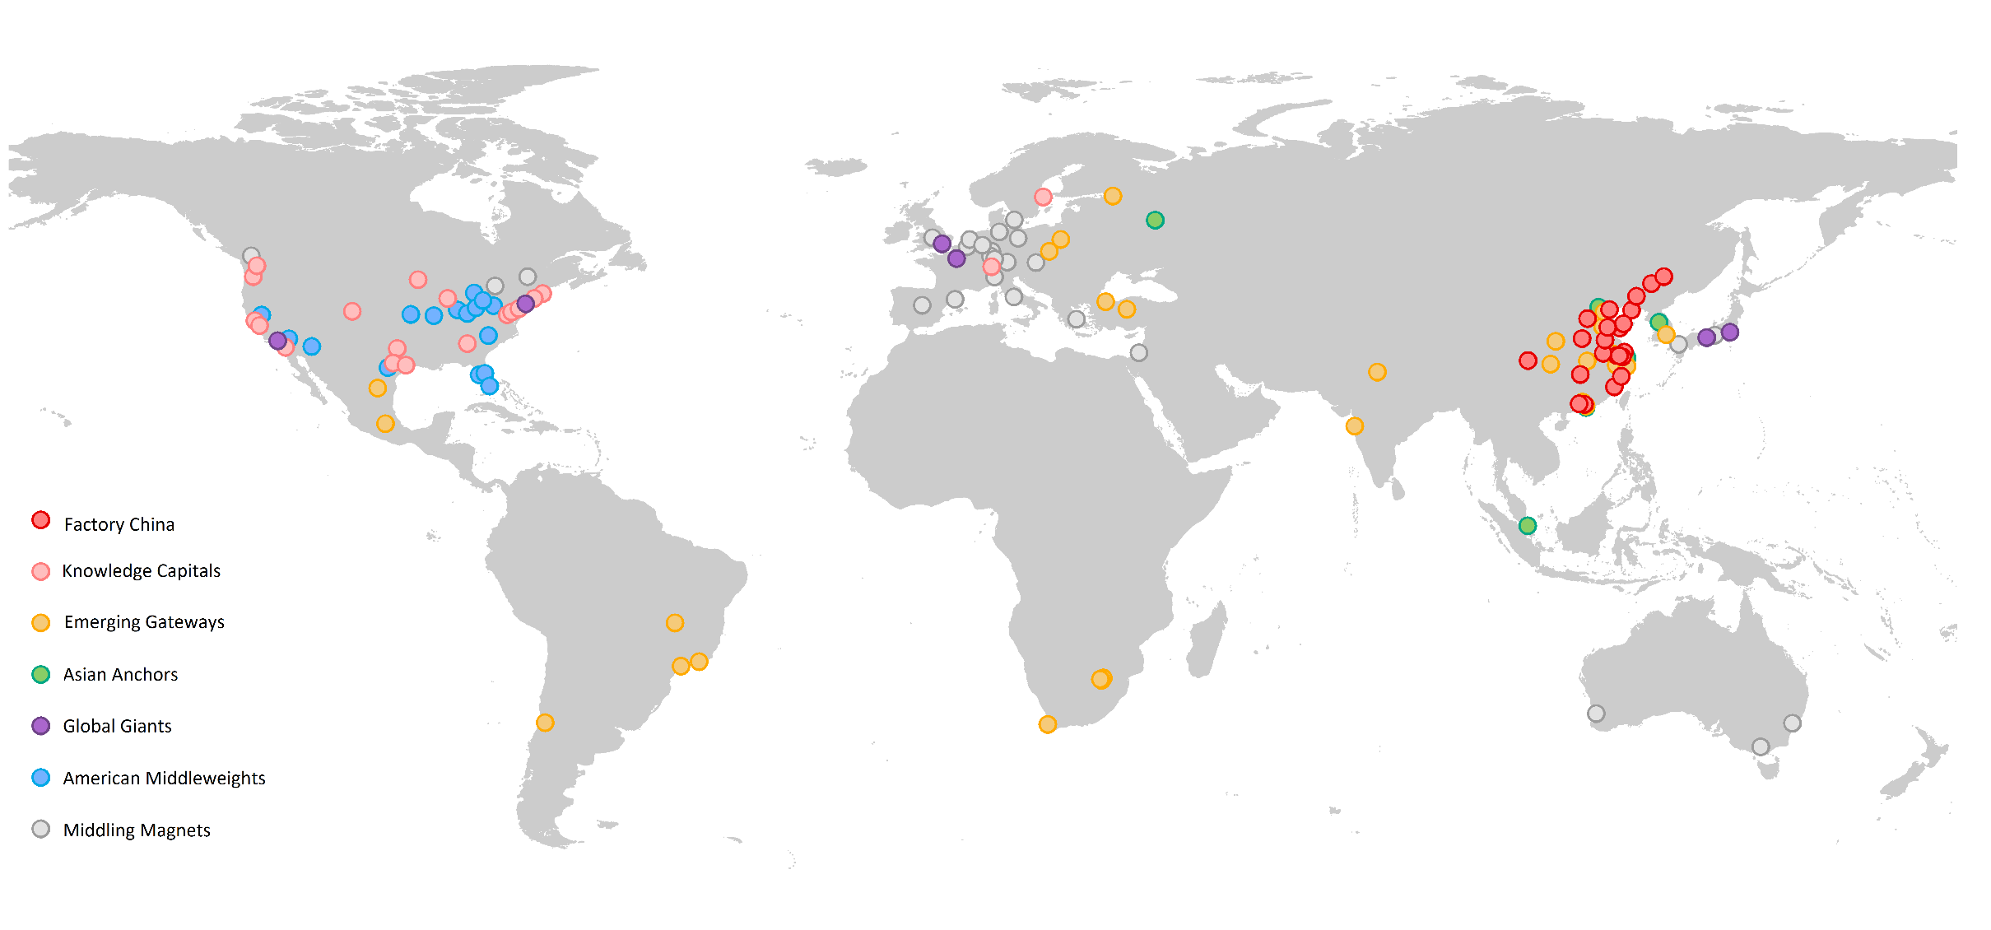

Grouped into seven metropolitan clusters, the distinct competitive positions of the world’s largest metro economies become sharper, as do the peers metropolitan areas can look to for common solutions and investments to enhance economic growth:

* **Global Giants (6):** large, wealthy financial hubs that serve as the command and control centers for the world’s largest advanced economies.
* **Asian Anchors (6):** six large, business and financial nodes anchoring inward investment into Asia.
* **Emerging Gateways:** 28 large business and transportation entry points for major national and regional emerging markets in Africa, Asia, Eastern Europe, and Latin America.
* **Factory China:** 22 second and third-tier Chinese cities distinctly reliant on export-intensive, manufacturing to power economic growth and global engagement.
* **Knowledge Capitals:** 19 mid-sized, highly productive knowledge creation centers in the United States and Europe with talented workforces and elite research universities.
* **American Middleweights:** 16 mid-sized U.S. metro areas striving for a post-recession niche in the global economy that must rely on anchor assets to propel transitions to more productive growth.
* **Middling Magnets:** 26 mid-sized cities in Australia, Canada, and Europe globally connected by people and investment flows, but where growth has lagged after the financial crisis.

**Global Giants**

**Global Giants** serve as the command and controlcenters of the world’s largest advanced nations. This group includes the largest cities in the United States (New York and Los Angeles), Japan (Tokyo and Osaka-Kobe), France (Paris), and the United Kingdom (London). These metro areas not only serve as the main entry points for their extremely powerful nations, but as the world’s most significant concentrations of wealth, corporate decision-making, and international exchange.

**Map 2. Global Giants**

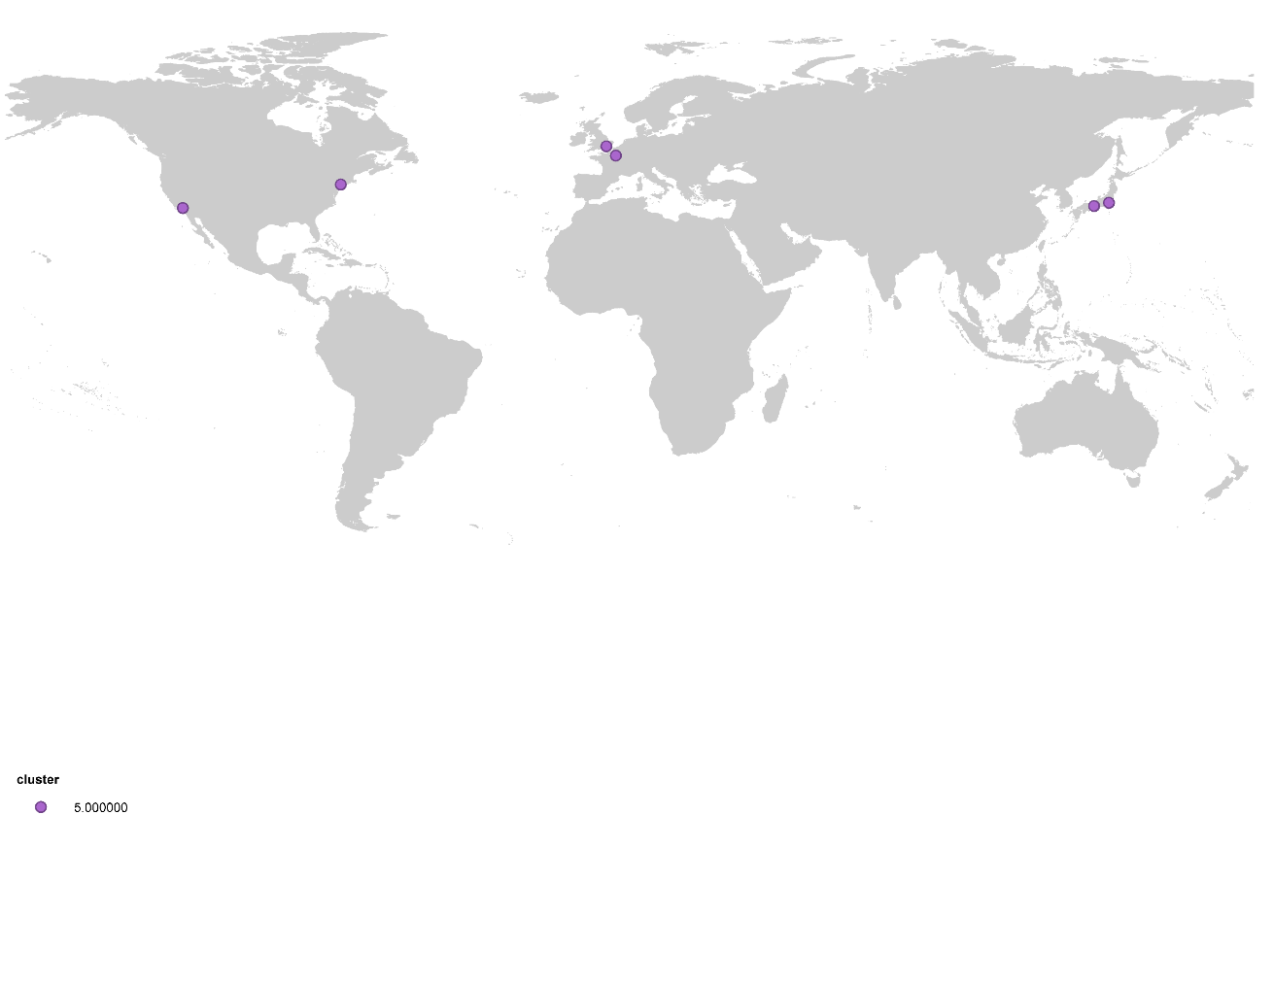

**Figure 2. Global Giant Indicators**

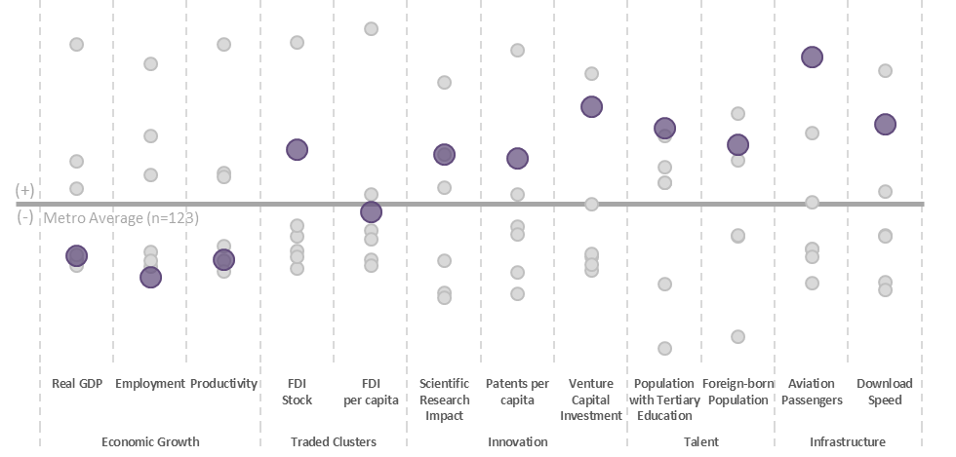

The first characteristic that binds these metro areas together is their sheer size. On average, Global Giants house 19.4 million residents and generate over $1 trillion in real output, the latter being three times larger than the next largest set of economies (Asian Anchors). If grouped into one sovereign nation, they would be the third largest economy in the world. Beyond their overall economic clout, these metro economies are highly productive and generate enormous wealth. They have the second highest average GDP per person ($58,000) and GDP per worker ($116,000) among the clusters, only behind the Knowledge Capitals.

**Figure 3. Metropolitan Real Gross Domestic Product (PPP, $ Millions)**

These wealth levels stem from the incredible concentration of financial and business services in these markets. Those sectors generate 41 percent of gross value added, on average, in this group. About 20 percent of the Forbes Global 2000 locate their headquarters in these six markets.[43] Five of the world’s seven largest stock exchanges, by market capitalization, are headquartered in these cities. Dense clusters of advanced producer services firms in law, accounting, management consulting, and advertising have formed to support the complex decision-making occurring in the financial markets and board rooms of multinational firms.[44]

**Figure 4. Gross Value Added by Type of Service**

These are also the world’s major nodes for flows of people, capital, and knowledge. In 2014, over 800 million aviation passengers traveled through these markets, by far the highest average of any cluster. Global travelers often stay to live and work; a little under one in six residents of a Global Giant is foreign-born.[45] Capital flows seamlessly through Global Giants. Foreign investors parked an average of $25 billion in these markets between 2009 and 2015, the second highest after the Asian Anchors. Finally, knowledge creation is increasingly a major function of these metro economies. Among the seven clusters, they have the highest education levels, second highest patenting rates, and second highest share of high-impact scientific publications in their universities. Every metro area except Osaka is among the top 15 globally in terms of digital data flows.[46] And venture capital investment data reveals that they are also sites of budding entrepreneurship scenes, especially in London and New York.[47]

By nearly every measure these cities are globally integrated and fluent. In fact, Saskia Sassen mainstreamed the phrase “global city” in her 1991 book about London, New York, and Tokyo. The world’s mobile talent and capital seeks them out, and they have benefited from multiple cycles of high demand.[48] For Global Giants the main challenge will be managing growth and global engagement in a way that furthers economic opportunity for a broad swath of the population, not a marginal global elite.

**Asian Anchors**

**Asian Anchors** are a Pacific-oriented cluster of economically powerful cities. These six metro areas—Beijing, Hong Kong, Moscow, Seoul-Incheon, Shanghai, and Singapore—have many of the same characteristics as their established counterparts in Europe, Japan, and the United States, but are not yet as wealthy and globally connected.

**Map 3. Asian Anchors**

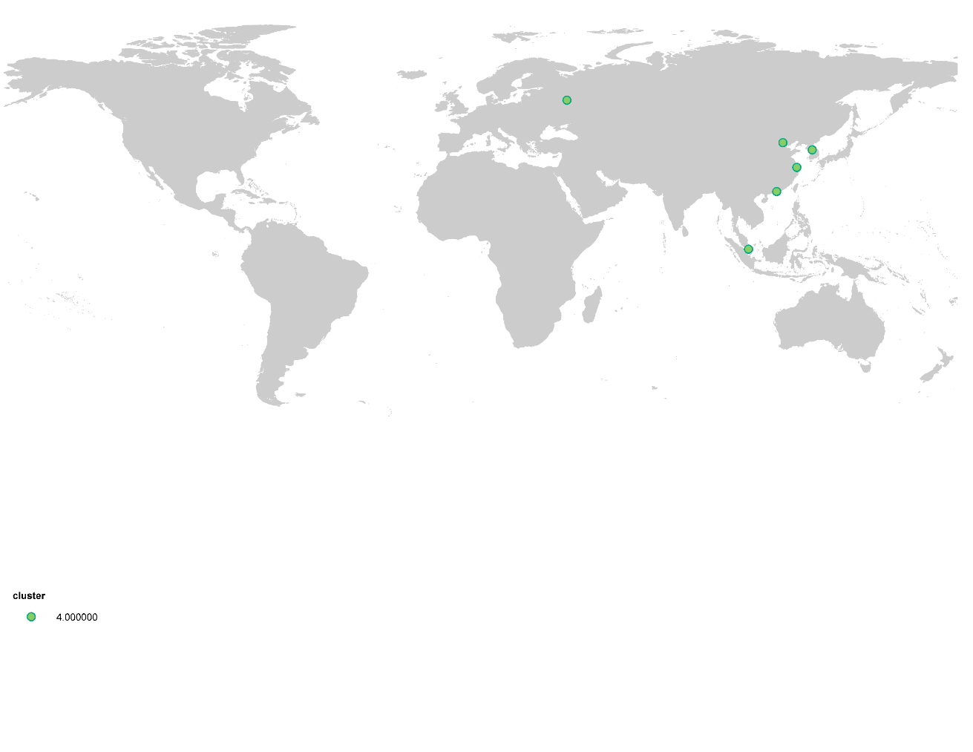

**Figure 5. Asian Anchors Indicators**

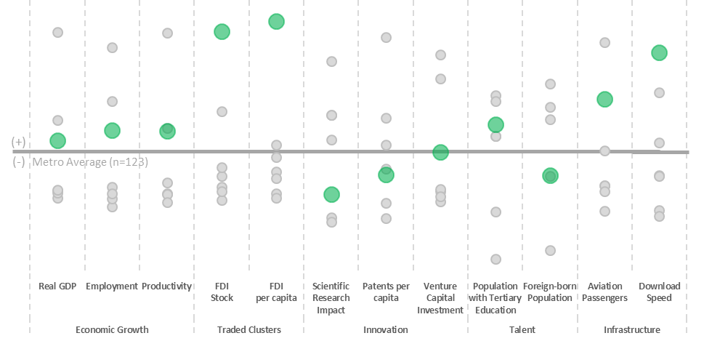

The rise of Asian Anchors has everything to do with the rise of Asia. The ascent of the Asian Tiger economies followed by the gradual liberalization of China and Russia positioned these cities as the gateways between the global investment community and their fast-growing nations. Those foreign investment streams brought new industries and capabilities to many of these cities, which have since been bolstered by local investments in infrastructure and skills.

Asian Anchors are now among the largest concentrations of people and market activity in the world. These metros have an average population of 16.1 million and an average real GDP of $332 billion, the second largest figures, respectively, among our seven clusters. GDP per capita in these regions has grown by a robust 4.2 percent per year since 2000. With an average GDP per capita of around $26,000, Asian Anchors are about half as wealthy as their advanced economy counterparts but are now firmly rooted in the global middle class. Interestingly, this average masks significant differences in real GDP per capita between the wealthiest metros in this cluster, Singapore ($49,000) and Hong Kong ($36,000), and the lowest income metros, Shanghai ($14,000) and Beijing ($13,000). In line with convergence theory, the lower income city-regions in this cluster have seen the fastest income growth since 2000.

Despite their disparities in wealth, several characteristics bind Asian Anchors in one cluster. First, the generous inflows of foreign direct investment (FDI) distinguish these regions from the rest of the world. On average, $46 billion in Greenfield FDI entered each of these markets between 2009 and 2015, nearly double the total of next highest cluster average. No metro areas in the world attracted more FDI than Hong Kong and Singapore during this period, and Beijing and Shanghai were not far behind. These cities provide a distinct value proposition for foreign investment: 1) they afford access to a rapidly growing Asian consumer market; 2) they provide strong infrastructure connectivity and relatively well-educated workforces; and 3) they offer a more certain regulatory and political environment than many peers in the region. It is notable, therefore, that Moscow has not kept pace with the other Asian metros in this cluster in regards to FDI attraction.

Figure 6. Greenfield Foreign Direct Investment (2009-2015, $ Millions)

These metro areas, along with Tokyo and Osaka-Kobe, are where Asia’s business gets done. About 32 percent of gross value added in these six metros is generated by financial and business services, 10 percent of Global 2000 firms are headquartered in these markets, and major stock exchanges are located in Shanghai, Hong Kong, and Seoul. Singapore is a significant financial trading hub in its own right. And 41 percent of Moscow’s GVA is in financial and business services.

Yet, labor productivity in this sector is only about one-third as high as in Global Giants, revealing that much work needs to be done to move further up the value-added chain. These metro areas are not yet on par with their Western counterparts in terms of patenting intensity or the scientific impact of their universities, although they can be considered the innovation hubs of their respective countries. Beijing and Shanghai together generate 23 percent of China’s patents, Moscow generates 55 percent of Russia’s patents, and Seoul-Incheon generates 67 percent of South Korea’s patents. Patents per capita increased by 78 percent across the cluster between 2007 and 2012. And the share of scientific publications generated in these markets that can be considered “high-impact” increased by 18 percent between 2009 and 2013, the second fastest increase among the seven clusters. Building on these gains to raise productivity is an urgent challenge in these regions, and investments in skills and technological innovation are needed to propel them to the next stage.

**Emerging Gateways**

**Emerging gateways** are large metropolitan areas from developing economies that serve as the business, transportation, and oftentimes political centers of their countries and regions. Nearly one-third of the cities in this cluster are the official capital of their respective countries (e.g. Ankara, Brasilia, Cape Town, Mexico City, Pretoria, Santiago, Warsaw, etc.). In fact, eight of the metropolitan areas in this group house the largest national stock exchange, serving as the financial centers of their countries and an entry point for a market that provides financial services to 3.1 billion inhabitants. Many of these cities served as the focal point of their national economies as they opened up and liberalized their markets for flows of trade, investment and people at the end of the 20th century.[49]Additionally some of these cities also serve as gateways for entire regions, as is the case for São Paulo, Rio de Janeiro, and Santiago in South America; Istanbul connecting the Middle East and Europe; Johannesburg as the business hub of sub-Saharan Africa, and Shenzhen as major complementary business hub in China to Beijing, Hong Kong, and Shanghai.[50]

**Map 4. Emerging Gateways**

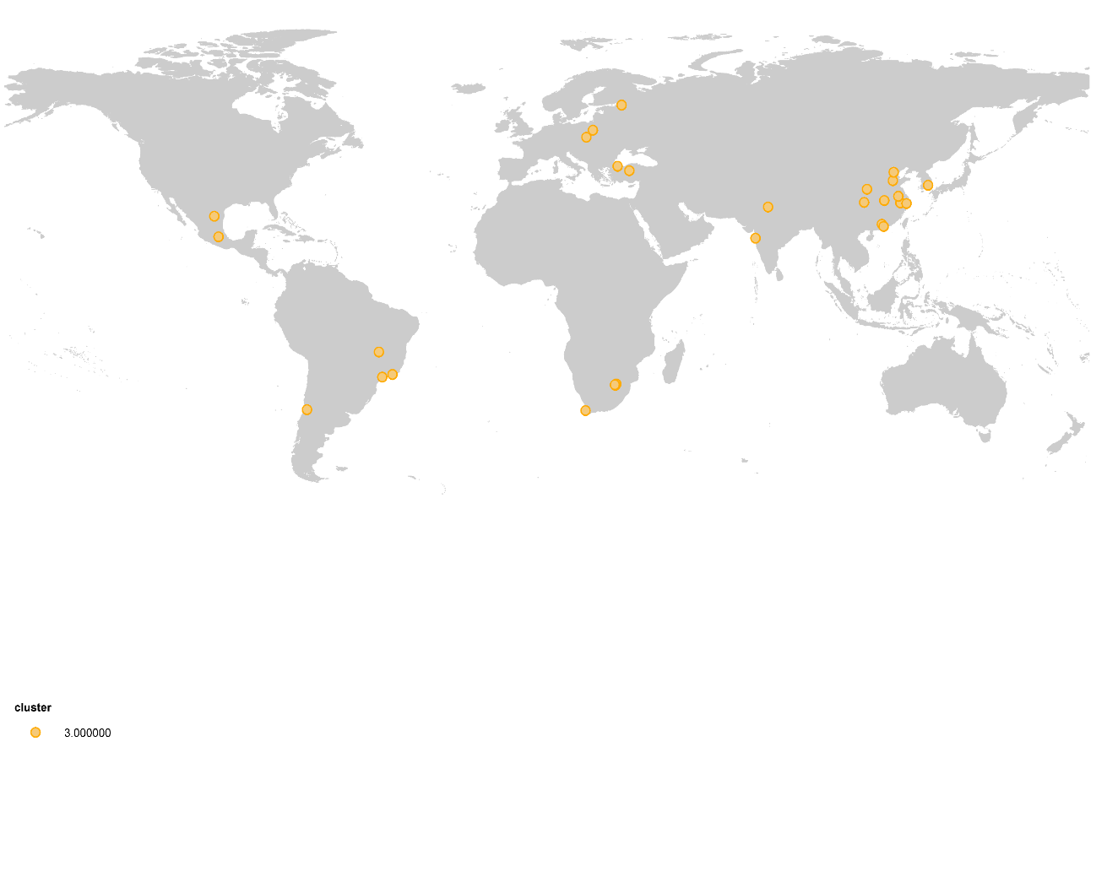

**Figure 7. Emerging Gateways Indicators**

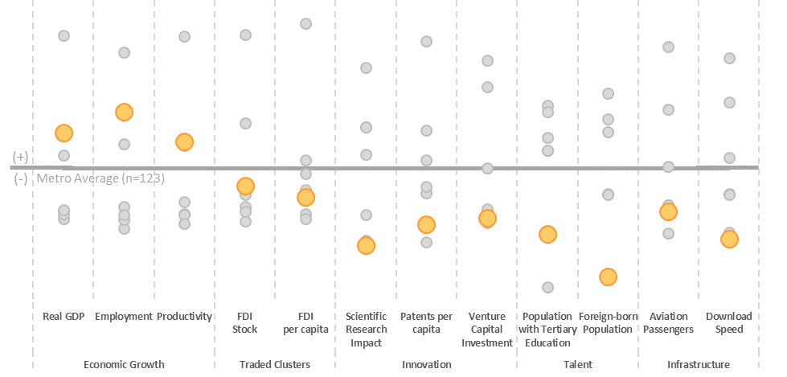

Metropolitan areas in this group house on average 10 million inhabitants and have an average real GDP of $126 billion, with some mega cities boasting economies of more than $400 billion (São Paulo, Guangzhou, Shenzhen, Mexico City, Tianjin, Istanbul and Chongqing). The average inhabitant of these metro areas entered the global middle class over the past 15 years. Real GDP per capita in emerging gateways has grown 5.5 percent annually since 2000 (second fastest after Factory China metros), and now stands around $14,000. Asian metro areas in this cluster experienced greater GDP per capita gains (8.1 percent annually) between 2000 and 2015 than their Latin American (3.2 percent) and African counterparts (3.6 percent).

Many of the cities in this group have led their national economies manufacturing booms in previous cycles and are already transitioning to a service-based economy. These regions disproportionately concentrate their nation’s competitiveness assets. All the cities in this cluster have a higher share of their working age population with tertiary education than their national economies. Many are home to their nation’s only globally relevant research universities. Cities like Istanbul, Santiago, São Paulo, Shenzhen and account for more than 40 percent of all the patents produced in their countries. Business, professional and technical services accounted for 25 percent of total output in these metro areas. However, the productivity of the average worker in this sector is a fifth of their peer metros in the Knowledge Capitals, Global Giants, and Asian Anchors clusters.

**Figure 8: Output per worker in Business, Financial and Professional Services in 2015 (2009 Real $)**

Emerging gateways are the entry points for global flows of people and capital. They typically house the most connected international airports of their nations. In 2014 the airports in these metropolitan areas transported 800 million passengers, up from the 273 million they connected in 2004. In fact, the average metro in this cluster registered the second fastest annual passenger growth rate among all other clusters, only behind Factory China, at 3.5 percent.

**Figure 9: Aviation Passengers Annual Growth, 2004-2014**

Metropolitan areas in this group received FDI flows of $58 billion between 2009 and 2015, which supported more than 175,000 new jobs. On a per capita basis, however, these investment flows trail most of the other clusters. They are not yet on par with the Global Giants in terms of international business or with Knowledge Capitals in terms of global innovation, although their prominence is growing quickly. FDI flows doubled between 2011 and 2015 and the stock of venture capital investment grew by 300 percent from $4.3 billion in 2010 to $14.1 billion in 2015.

Emerging gateways still function primarily as national hubs for transport, businesses and services, their relevance stemming from their connections to billions of emerging market residents. However, to complete with other metros that serve as truly global hubs of services, several challenges need to be addressed. These urban centers agglomerate innovation and research assets, yet they have not translated those advantages into advanced industrial specializations. They produce 50 percent fewer patents per capita than their Asian Anchor peers, and only 7 percent of the scientific articles published in their universities are referenced in the most-cited scientific journals. Catch-up growth allowed these metro economies to reach middle-income status, but advancing incomes further will require a targeted focus on boosting their knowledge economies.

**Factory China**

The **Factory China** cluster is comprised of Chinese manufacturing hubs. The 22 cities in this group are a good representation of the geographic diversity of China’s industrial revolution. Factory China includes metros on China’s east coast (Hefei and Nantong), inland regions (Chengdu and Zibo), and the Pearl River Delta (Foshan and Dongguan).

**Map 4. Factory China**

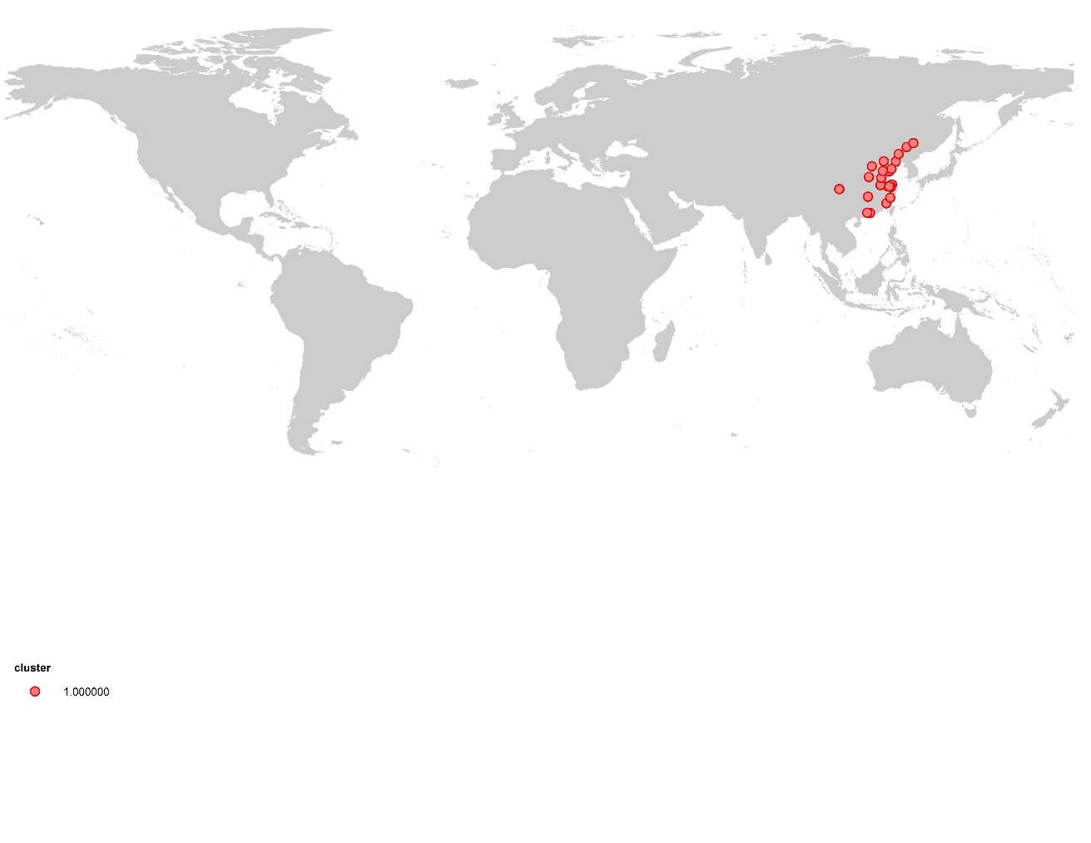

**Figure 10. Factory China Indicators**

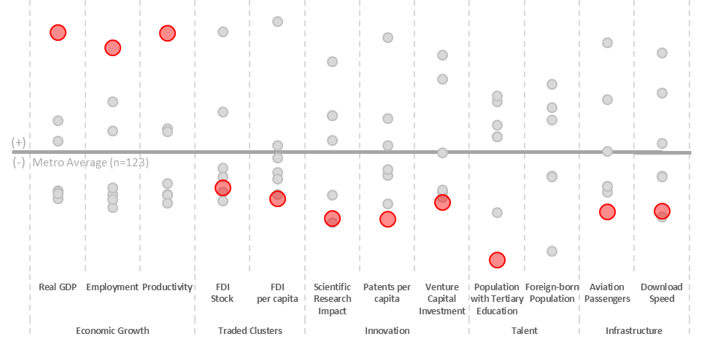

Factory China comprises China’s second and third-tier population centers that are growing incredibly quickly. The typical city in this group has an average population of 8 million and a real GDP of $96 billion. Output and employment have grown in these metros by an outstanding 12.6 and 4.7 percent annually between 2000 and 2015, the fastest pace among our seven clusters. GDP per capita has expanded fivefold since 2000, from $2,500 to $12,000, rooting these metros firmly in the global middle class.

**Map 5. Factory China Metropolitan Areas Close-up**

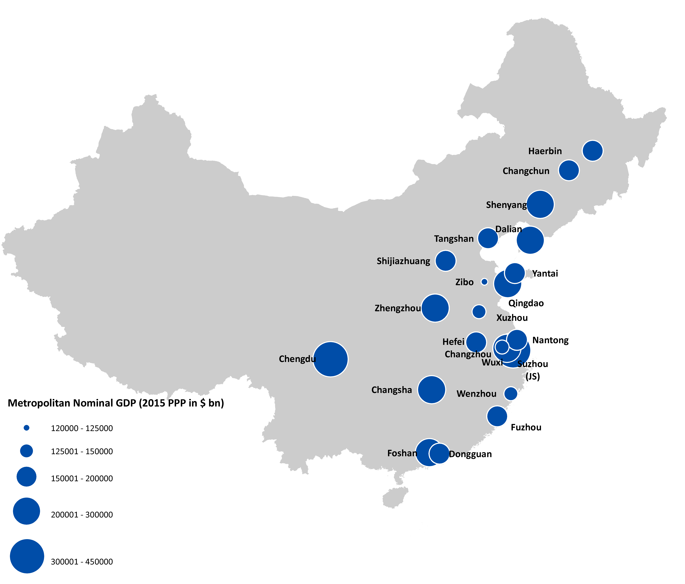

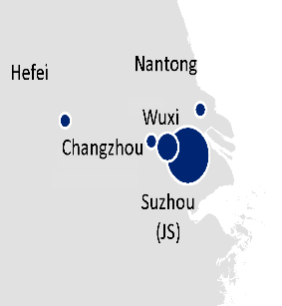

The most salient feature this cluster is their extreme reliance on manufacturing, which accounts for nearly 40 percent of total output, the highest of any cluster. In fact, cities in this cluster are more manufacturing-intensive in 2015 than they were in 2000, when manufacturing accounted only for 30 percent of their GDP. With only 25 percent of national population, Factory China metros generate one-third of China’s total manufacturing value-added ($800 billion).

**Figure 11. Manufacturing share of real GVA in 2015**

Factory China metro areas plug into the global economy as nodes in international manufacturing supply chains, typically providing goods to wealthier consumer markets in advanced economies. Multinational corporations like Unilever (Hefei), Goodyear (Dalian), Samsung (Dongguan), DuPont (Dongguan and Changshu), Intel (Dalian), Pfizer (Dalian and Hangzhou), Dell (Chengdu), anchor manufacturing operations in Factory China.[51] This specialization has proved very effective in building wealth, and moving millions of Chinese households into the global middle class. But it is one-dimensional, and has come with significant environmental costs. The heavy industrial activity has resulted in pollutant levels that are 40 times above what the World Health Organization allows, and 40 percent of China’s rivers are polluted.[52]

To continue to boost incomes, Factory China metros will have to diversify from manufacturing to services. Currently, business, financial, and professional services—economic activities typically associated with urban agglomeration—account only for 12 percent of total output in this cluster, well below the average of 32 percent for the other groups. The lack of economic diversification partly explains why cities in this cluster rank last in flows of FDI, venture capital attraction, and international passengers. Additionally, only 13 of the cities in this group contain a top-ranked research university. Factory China metros invent only 0.03 patents per 10,000 employees, and less than 10 percent of the population 15 years or older has tertiary education. If Factory China metros are to take the next step, it will be because they are able to bolster these competitiveness factors.

**Knowledge Capitals**

**Knowledge Capitals** tend to be mid-sized population centers that are among the wealthiest and most productive in the world. This group of 19 metropolitan economies has an average population of 4.2 million, the second smallest cluster, by population. But because they are so productive, these metro areas have the third highest average economic output ($260 billion).

**Map 6. Knowledge Capitals**

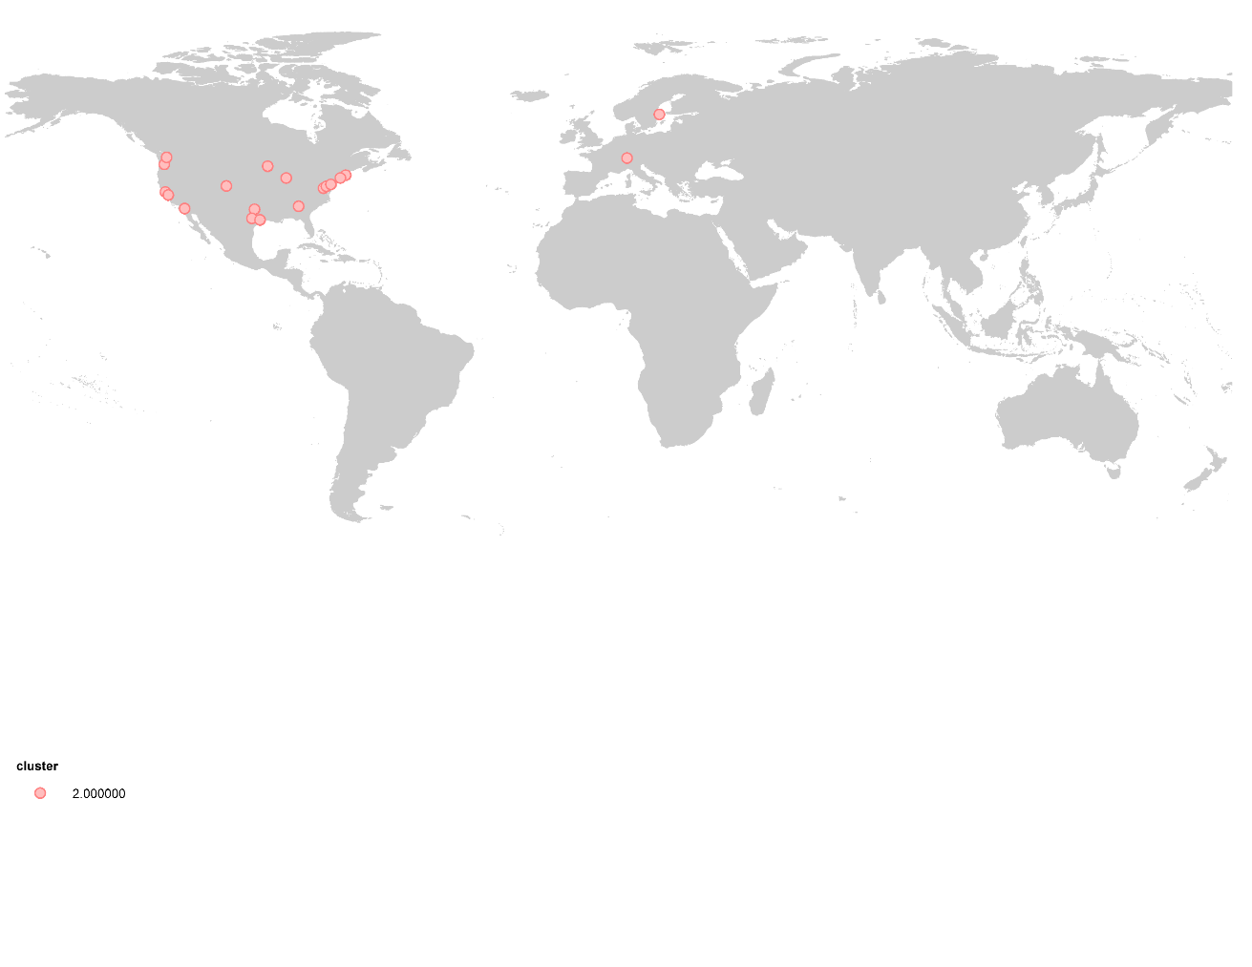

**Figure 12. Knowledge Capitals Indicators**

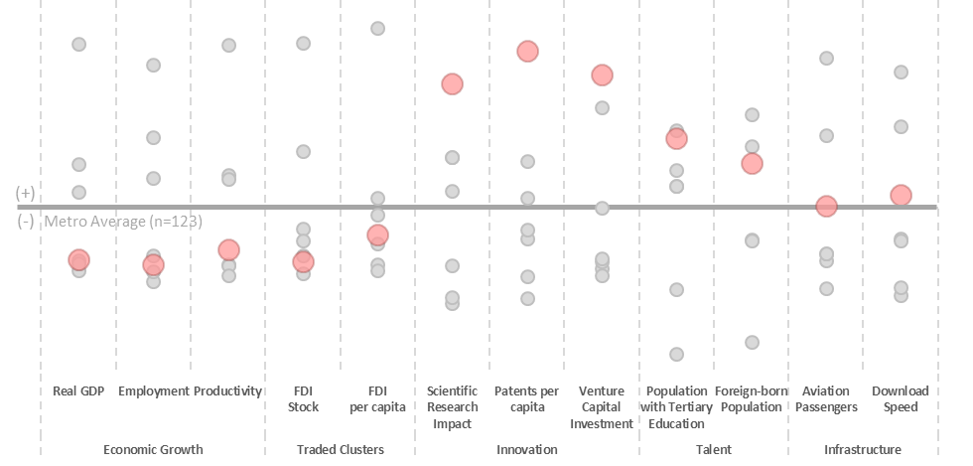

Knowledge Capitals are the world’s leading knowledge creation centers. They compete in the highest value-added segments of the economy, relying on their significant stock of human capital, innovative universities and entrepreneurs, and relatively sound infrastructure connectivity.

These places are supremely well-educated; 41 percent of their 15-and-over-population has obtained a college degree. Many of these are graduates from the elite research universities that anchor these metro economies distinct position in science and technology. Universities in this cluster boast the largest share of highly-cited scientific publications. Of the 100 most scientifically impactful universities in the world, 20 are located in these cities.

Scientific research tends to translate to new inventions in these regions, which have, the highest average rates of patenting in the world. With only about 1 percent of the world’s population, Knowledge Capitals generated 16 percent of global patents between 2008 and 2012, and even higher shares of information technology (22 percent) and life sciences (19 percent). Many of these regions also foment high-growth companies. This cluster has, by far, the highest venture capital investment rates per capita in the world, led by San Jose, San Francisco, and Boston. More than half of all global venture capital funding flowed to these 19 markets over the past decade.

Figure 12a. Knowledge Capital Metro Shares of Innovation Assets

Finally, controlling for their population size, these metro economies have the greatest volume of aviation passengers in the world, signifying the substantial flows of business and leisure travelers flocking to these places. However, foreign direct investment inflows are not as substantial as other clusters, revealing that, for all their assets, many of these mid-sized metros must proactively assert their visibility in the global marketplace.

Knowledge Capitals overwhelmingly are located in the United States. All but two (Stockholm and Zurich) are U.S. cities, including well-known coastal innovation hubs like Boston, San Francisco, San Jose, and Seattle. But it also includes metro economies in the Midwest (Chicago, Minneapolis-Saint Paul) and South (Atlanta, Austin, Dallas, Houston), which now tend to compete in technology-intensive advanced industries across both manufacturing and services.[53] Stockholm and Zurich represent two of Europe’s wealthiest and most productive economies, specializing in professional, scientific, and technical services, finance, and information technology. Overall, output per worker in these metro areas is 9 percent higher than the next most productive cluster.

Knowledge Capitals are not only more productive than the rest of their advanced economy peers, the gap is widening. Between 2000 and 2015, annual GDP per capita and GDP per worker growth averaged 0.9 and 1.4 percent, respectively, in innovative middleweight metro areas. This is by no means a blistering pace, but these growth rates are 37 percent and 69 percent faster, respectively, then average growth rates across the other three advanced economy metro clusters. The key for these metros will be to double down on investments in skills and innovation to maintain a competitive industrial edge.

**American Middleweights**

Sixteen cities form the **American Middleweights** cluster. Metropolitan areas in this group are almost evenly divided between mid-sized production centers in America’s north and east (Cincinnati, Cleveland, Pittsburgh, Indianapolis, Detroit) and southern cities that have experienced significant population growth (Miami, Phoenix, Orlando, St. Louis, Tampa, Sacramento). The average metropolitan area in this group has 3 million inhabitants, generates $135 billion in real output, and has a GDP per capita of $43,000.

**Map 7. American Middleweights**

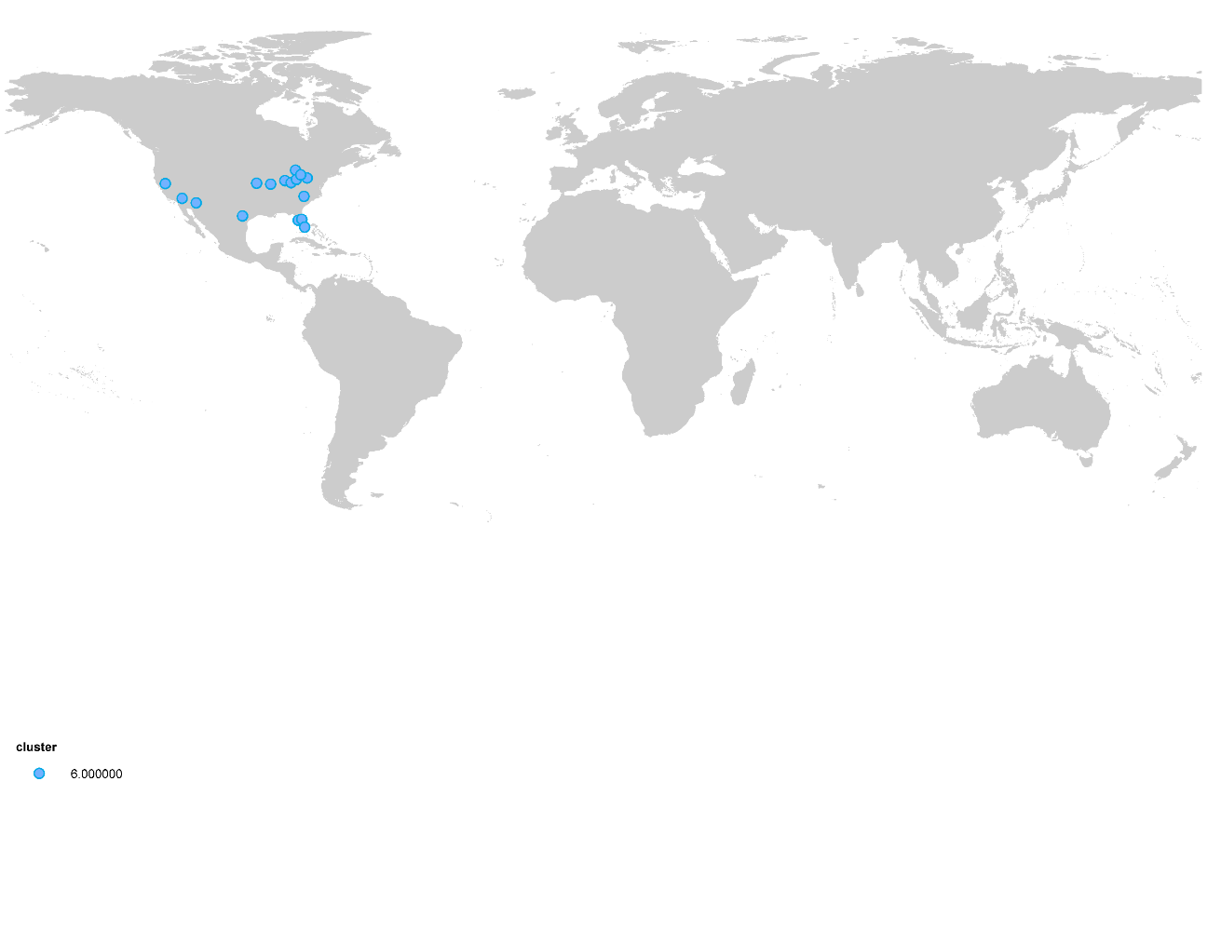

**Figure 13. American Middleweights Indicators**

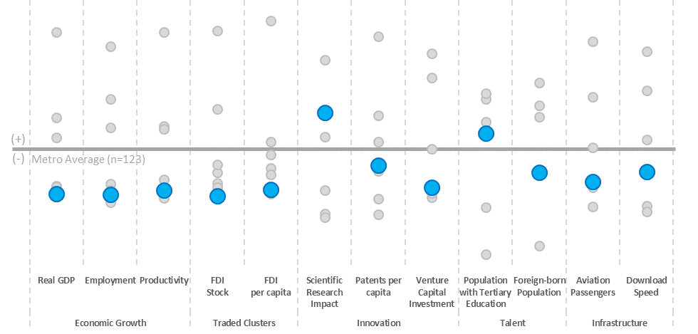

Overall output (1.6 percent), GDP per capita (0.4 percent) and employment (0.7 percent) growth has lagged most other clusters between 2000 and 2015. American Middleweights have the highest concentration of local services (health care, real state, education, public services) of all clusters. Local services account for 27 percent of output and 42 percent of employment. This sector was also the fastest growing part of the economy for the average city in this group, posting an annual growth rate of 1.3 percent between 2000 and 2015. Cities in this group are striving to find their global niche. Tradable industries account for the lowest share of output among any cluster.

|  |  |
| --- | --- |
| **Figure 14a: Share of output in traded sectors** | **Figure 14b: Share of output in local services** |
|  |  |

The prevalence of the local services accentuated the impact of the 2008 economic and financial crisis, particularly in Sunbelt cities which relied heavily in construction and real estate development to power economic growth.[54] Between 2008 and 2010 the construction sector shrank 11 percent per year, the highest drop among all the clusters, while the average home lost 29 percent of its value between 2008 and 2012.[55] Cities like Detroit, Miami, Orlando, and Phoenix saw home price declines of more than 30 percent.

At the same time, the manufacturing sector—once the engine of export-led growth in places like Cleveland, Detroit and Pittsburgh, Detroit—has seen its share of output and employment decline relatively to other sectors of the economy.[56] Due to automation and strong competition from abroad, manufacturing employment declined 2.1 percent annually since 2000. Today, manufacturing accounts only for 7 percent of total employment in this cluster.

Despite the lackluster performance, American Middleweights house durable assets that will be critical drivers of their continued economic transition. Many of these regions have well-regarded research universities. This cluster ranked third in the share of scientific publications in the top ten percent most cited academic journals. One-third of the working-age population in these markets boasts a tertiary degree, also third among all clusters. Venture capital flows per capita rank third among clusters as well. In the wake of Great Recession, these metro areas must reboot their tradable industrial base. A combination of skilled workers and a greater focus on export-intensive, advanced industries can propel the next wave of growth in these regions.

**Middling Magnets**

**Middling Magnets** include a diverse group of relatively wealthy cities in Canada (Toronto, Vancouver), Europe (Brussels, Berlin, Munich, Rome, Milan, Munich), Asia (Kitakyushu-Fukuoka, Nagoya and Tel Aviv), and Australia (Sydney, Melbourne). These 26 metros have an average population of 4.8 million, output of $236 billion, and GDP per capita of $49,000, third highest among our clusters.

**Map 8. Middling Magnets**

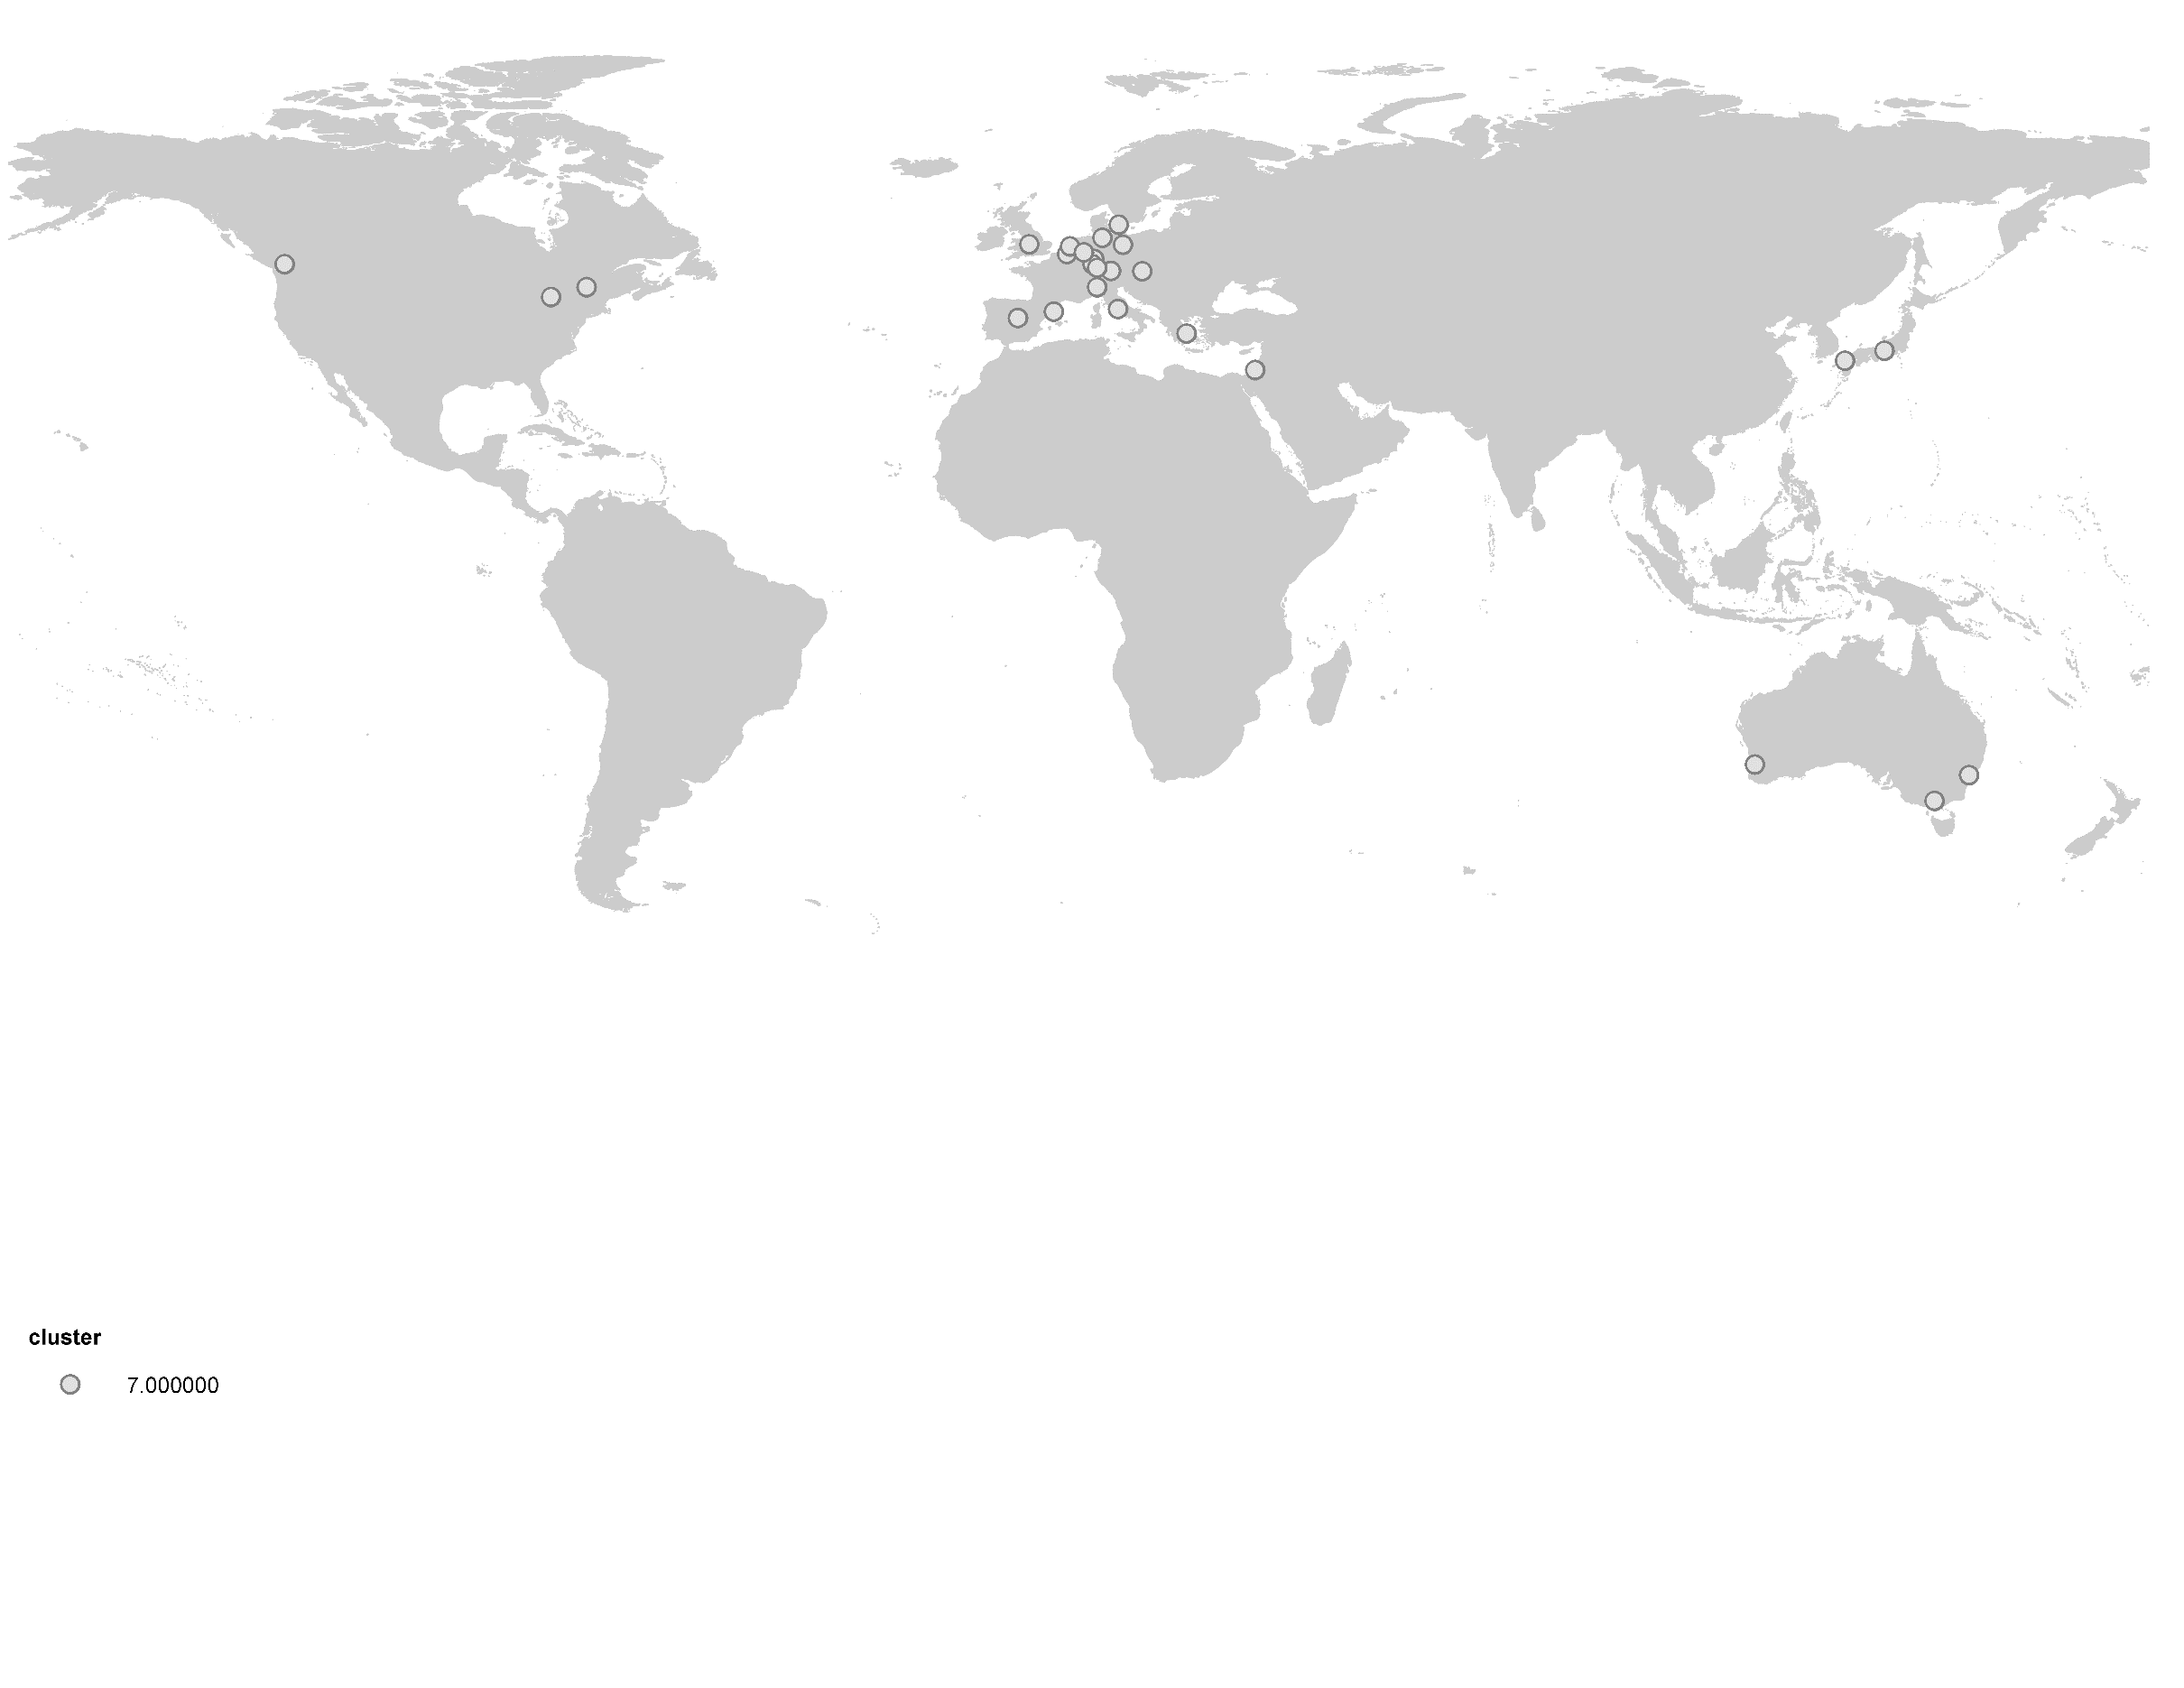

**Figure 15. Middling Magnets**

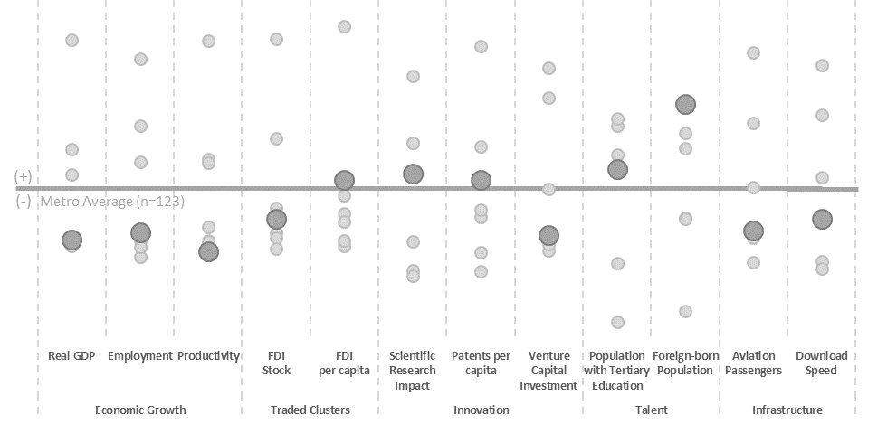

This cluster houses the most varied group of metro economies. Cities like Toronto, Sydney, Frankfurt, Madrid and Copenhagen play a fundamental role in the provision of business and financial services in their national and regional economies. In parallel, industrial centers such as Kitakyushu-Fukuoka, Nagoya, Stuttgart, Karlsruhe, Milan and Barcelona, generate significant levels of manufacturing value-added in Japan, Germany, and Southern Europe, respectively. Most have diversified tradable sectors that tend to specialize in knowledge services, advanced manufacturing, or some combination of both.

Several shared characteristics bind diversified middleweights. First, they are quite globally connected by migration and capital flows. About 22 percent of the population in these cities are foreign-born, the highest share among any cluster. Similarly, these metros boast the second highest level of foreign direct investment per capita, with almost $2,000 dollars of FDI stock per inhabitant. These metros are well-educated (33 percent of the working age population has tertiary education); house elite universities (the highest number of research universities of any cluster on both an absolute and per capita basis); and generates new knowledge (third highest rate of patenting intensity).

**Figure 16: Total number of world ranked research universities**

For Middling Magnets, unfortunately, another characterization they share is sluggish economic growth. Between 2000 and 2015, output, GDP per capita, and employment grew 1.6, 0.7 and 1.0 percent annually, all among the three slowest-growing clusters. Further, the international financial crisis of 2008-2009 divides the economic trajectory of this group of cities. Output, GDP per capita and employment all grew faster in the 2000-2007 period than in the following years. As a result, 12 cities in this group have yet to return to their pre-crisis GDP per capita levels and five cities have yet to regain their pre-crisis employment base.

The sluggish growth highlights the importance of addressing some structural issues hindering these cities. On average, one quarter of the GDP is generated by local services, second highest among all the other clusters. Additionally, the productivity levels of the cities in this group are not yet on par with other advanced economy clusters, which is particularly worrisome given their population and labor force I shrinking. Overall productivity growth was the slowest among all clusters, and convergence does not seem likely without significantly shifting course. Lower levels of productivity and a high concentration of economic activity in local, non-traded services represent a challenge that these metropolitan areas need address if they wish to retain their global relevance.

**V. Implications**

Examining global city economies through this typology reveals three broad implications.

First, there is no one way to be a “global city.” The pervasiveness of globalization has linked metro economies in an international network that is simultaneously collaborative and competitive. Based on their competitive endowment, cities start from very different places. Technological innovation occurs in more cities than ever before, but it is distinctly driven by a set of U.S. and European mid-sized regions due to their world-leading research universities and innovative firms. Two sets of massive global centers—one in established nations and one in rising Asia—form the twin pillars of global finance and investment. They are complemented by a rising set of business, education, and transportation hubs that serve as global gateways to large, middle-income countries. Two additional groups of advanced economy metros—one concentrated in the United States and the other spread across Europe, Japan, and the UK commonwealth countries—are trying to deploy their relatively well-educated populations, industrial specializations in advanced manufacturing and business services, and university and airport anchor assets to maintain relevance globally. Our typology reveals multiple models for global engagement.

Second, not all cities are thriving equally in the global economy. Growth outcomes vary greatly. Unsurprisingly, lower income metro areas have experienced the fastest GDP per capita growth since 2000, led by Factory China metros. The trend towards convergence continues, although the pace is slowing. Within the developed world, Knowledge Capitals and Global Giants not only have higher average incomes, but have also experienced faster GDP per capita and productivity growth. The American Middleweights and the Middling Magnets, which include most of Europe, tend to not only have lower incomes but also lower growth. Bringing lagging metro areas closer in line with their faster growing peers will be critical to jumpstarting a slowing global economy.

**Figure 17. Real GDP per capita and real GDP per capita CAGR 2000-2015 for the seven clusters**



Note: Factory Asia = Factory China; Innovative Middleweight = Knowledge Capitals; Emerging Command and Control = Asian Anchors; Established Command and Control = Global Giants; Sun and Rustbelt = American Middleweights; and Diversified Middleweights = Middling Magnets

Third, local and national leaders must approach economic strategies with a clear-eyed understanding of their city-regions’ global starting point. In an urbanizing, globalizing, and technologically dynamic world, the assets that drive growth and prosperity—tradable clusters, innovation, talent, and infrastructure—are not evenly distributed across the globe, or even within nations. These clusters reveal broad groupings of cities that share similar characteristics and, perhaps, shared solutions. We explore priorities for action within each cluster below.

**Global Giants**

These city-regions are the most-connected nodes in the global economy, serving as the main hubs for international business, travel, and decision-making in their respective countries. They retain advantages that have been built up over decades, even centuries, and have proved durable over numerous business cycles. These markets house major international airports, globally-recognized universities, and large multinational companies that ensure global relevance for the foreseeable future. Yet, what has made them globally fluent metro economies in the first place has also created downsides: an overreliance on finance as an economic driver, high levels of inequality that are creating affordability pressures on low and middle-income households, and insufficient investments in housing and transportation infrastructure to accommodate large and growing populations.

Over the coming decades, these metro areas must both maintain their advantages in catering to large multinational headquarters and financial institutions while also fostering environments in which small, entrepreneurial firms can successfully bring new products and technologies to market. This involves securing a steady supply of technical talent and helping bridge relationships between universities, research institutions, and companies. New York City is helping finance a new applied science and engineering campus to ensure they have the STEM workers and research capabilities to commercialize new ideas. Similarly, the Île-de-France and French central governments are co-investing in Paris-Saclay, an ambitious effort to consolidate many of France’s most potent research institutions under one common brand and co-locate them in one geographic cluster about 45 minutes outside central Paris.[57] These commitments to technical skills and technological advances help position these metro areas to compete with innovative middleweight metros in the coming decades.

Industrial diversification must be accompanied by investments in housing—to ease affordability pressures—and transportation infrastructure—to establish the physical platform for the next business cycles. All six Global Giants are among the 15 most expensive cities in the world, according to the Economist Intelligence Unit.[58] Housing costs tend to be among the highest in the world. Since demand for housing in Global Giants tends to be global, and supply local, there is no easy fix here. Deploying a multi-pronged strategy that eases restrictions on housing supply, incentivizes affordable housing production, and coordinates housing, transportation, and land use planning can help ensure that households lower on the income ladder can continue to afford to live and work in these cities and contribute their needed complementary skillsets to the labor market. One of New York City Mayor Bill de Blasio’s major priorities has been an ambitious plan to build or preserve 200,000 units of affordable housing in 10 years.[59] Osaka and Tokyo tend to be more affordable than their Western counterparts due to liberal zoning policies, which allow for uniquely active housing construction markets.[60] At the same time, transportation investments can help ease affordable employment access for all residents. Ambitious transportation expansions, including Paris’s Grand Express, London’s Crossrail, and Los Angeles’s Measure R initiative, more sustainably position these large metro areas for the next round of growth.

**Asian Anchors**

Asian Anchors are widely considered to be some of the world’s most impressive examples of urban economic growth. As the global investment community’s entry points into Asia, they have thrived by providing relatively sound fiscal and investment environments, good infrastructure connectivity, and a relatively skilled workforce. Recent GDP per capita growth in these markets has been robust as a result. However, the model that brought Asian Anchors to this point will not be enough to drive continuous income growth in the coming decades. For that, these metro areas must focus intently on boosting productivity, embracing entrepreneurship, investing in education and skills, and addressing affordability and infrastructure concerns.

The six metro areas in this cluster share many priorities with Global Giants. They are also experiencing the pressures of global demand on affordability. According to the EIU, Singapore has the world’s highest cost of living, Hong Kong the third highest, and Seoul the eighth highest.[61] Their rapid expansion demands greater housing supply and transportation investments. In Beijing, for instance, planners are trying to coordinate subway and high-speed rail investments, coordinated high-density housing construction, and large-scale commercial developments as growth spills over into neighboring Tianjin and Hebei province. Plans to integrate the 130-million, 82,000 square-mile Jing-Jin-Ji megalopolis are some of the most ambitious in the world.[62]

Notwithstanding this priority, the greatest imperative for this cluster may be making the necessary investments in competitiveness to lift their populations into upper income status. These metro economies are no longer the “low-cost” option for firms and industries, forcing them to compete with developed metro areas based on the quality of their products and services. Yet, output per worker remains about one-third that of their Global Giant counterparts. Understanding this imperative, these cities are focused intently on upgrading the education and skills of their citizens. About 36 percent of residents in these markets have attained tertiary education, and expanding access to university and vocational education remains urgent.[63]

Encouraging new, nimble firm entrants, which help introduce new technologies and products to the marketplace, is one way to infuse new dynamism across both manufacturing and services industries. Through significant government support, Asian Anchors have developed world-beating corporations (e.g. Beijing-based Lenovo or Seoul-based Samsung, etc.). Singapore and Hong Kong are two of the leading destinations for large foreign subsidiaries. But can these regions organically generate new rounds of successful, home-grown companies that can compete successfully in global markets? National governments are investing in significantly in research and development (R&D) in these markets to gain footholds in emerging technologies. Singapore is pursuing an active industrial cluster policy to cement advantages in water technology, applied health sciences, and aerospace.[64] South Korea is trying to help Seoul firms move beyond their legacy as “fast followers,” providing top-down investments of up to 1 billion KRW (approximately $900,000) to support startups with research and development, capital raises, and global expansion.[65]

**Emerging Gateways**

The metropolitan areas in this group serve as the entry point to large emerging markets. They are the primary connection point to secondary and tertiary cities that are expected to generate significant economic growth in the coming decades. This position allows them to serve as hubs for advanced financial and business services and transportation. Emerging Gateways serve a similar function to Asian Anchors, but have yet to achieve as prominent a role. This is partly due to the fact that their markets are not yet the size of East Asia but also because the competitiveness factors required to generate new products and services are not as developed in these markets as in the Asian Anchors.

Many of the Emerging Gateways embraced globalization early on, consolidating their positions as beachheads for capital, ideas, technology, and people. This role allowed them to concentrate important competitive assets and become the knowledge and innovation centers of their respective countries. However, many of these cities, particularly those outside of Asia, have tended to underinvest in durable growth drivers like research and development and transportation infrastructure.

Attention to productivity is urgent. Emerging Gateways as a group trail all the other clusters in terms of output per worker and output per worker in the business, financial and professional services sector, a key industry for these cities. To tackle this challenge additional investments in education are required, not only to increase the share of working age population with tertiary education, but to also improve the quality of the skills provided. Brazil, Chile, Mexico, and Turkey all rank at the bottom of the OECD quality of education rankings.[66]

In terms of innovation these metro areas need to take advantage of their privileged position as magnets of knowledge and talent, at least within their respective nations and regions, to facilitate a transition towards higher value-added sectors. A closer collaboration between the private sector and universities should be among the top priorities for policymakers in this cluster. The steps that cities like Santiago are taking to bring together firms, entrepreneurs, universities, and the public sector will be paramount to unveil new avenues for economic growth.[67]

These metros serve as the transportation hubs for countries that connect nearly half the world’s population. Despite this status, however, Emerging Gateways metros rank fourth in air passenger traffic. Investing in global connectivity should be a priority for many of these cities. Mexico City is betting on transportation to power their economic growth, investing in a new airport that will be able to serve up to 50 million passengers per year, a vast improvement from the current capacity of 16 million passengers per year. Similarly, Santiago, Rio de Janeiro, and Warsaw are also investing to expand the current capabilities of their airports to allow for more seamless travel between their national markets and the rest of the world.[68]

**Factory China**

Factory China exemplifies its country’s assertion on the global stage. As these regions industrialized, drawing on robust global demand for locally manufactured products, GDP per capita grew by 400 percent between 2000 and 2015 in these 22 metro areas. Millions of Chinese residents moved into the global middle class in these places.

Accelerated growth has not come without costs. Life expectancy in cities like Changchun, Dalian, Haerbin, Qingdao, Shenyang, Shijiazhuang Tangshan, Yantai and Zibo are on average five years lower than in the rest of the country due to the air pollution that accompanied industry.[69] Population growth, climate change, and industrial demand are creating water shortages in Shijiazhuang, Tangshan, Changchun, Dalian, Shenyang, Qingdao, and Zibo.[70] Pricing these negative externalities must be a critical goal of energy, environmental, and industrial policy going forward.

Manufacturing will continue to be the growth engine in Factory China for the foreseeable future, but it may never provide the mass employment of the 2000s again. Accelerating automation and the shift in global supply chains to new, lower-cost markets may limit the benefits of industrialization in many of these metros. New evidence already suggests that manufacturing is experiencing diminishing returns in raising the living standards in developing nations.[71]

Factory China metros must spur an industrial transition through productivity-enhancing investments. Supporting education and workforce training is paramount for higher value-added industries to thrive. Just as major investments in land grant universities did in the United States, China can bring these second and third-tier cities into the 21st century by improving the scientific impact of their universities. Investments in infrastructure will be critical to address environmental and mobility concerns.

In the past industrial powerhouses who underinvested in their prime competitive assets have struggled to successfully compete in an ever changing and demanding global economy. [72] For Factory China metros, a long-term strategy that addresses both environmental issues alongside investing in the fundamentals of competitiveness ae necessary if they wish to sustain growth levels that continue their remarkable income gains.

**Knowledge Capitals**

These American and European metros have achieved high-wealth status due to their significant stocks of human capital, innovative firms and universities, and sound infrastructure connectivity. Unlike the Global Giants, they are not the primary city-region in their national or supranational systems and are not necessarily global centers of finance. Rather, they oftentimes operate at a smaller scale as regional hubs of business and professional services in their respective countries (e.g. Atlanta in the American South, Minneapolis in the American North, Denver in the American Mountain West, or Stockholm in Scandinavia) and key transportation nodes (e.g. major international airports in metros like Atlanta, Chicago, and Dallas).

Where Knowledge Capitals maintain truly global relevance is in knowledge creation and commercialization. These are the world-leading centers for new ideas and technologically advanced products. Silicon Valley—anchored by San Francisco and San Jose—is arguably the world’s leading innovation ecosystem, best known for its breakthroughs in biotechnology, information technology, and digital services. But this grouping of metros also includes other global nodes of information technology (San Diego, Seattle, and Stockholm), life sciences (Boston and Philadelphia), medical technology (Minneapolis), and semiconductor manufacturing (Austin and Portland). If, as Richard Freeman argues, “knowledge creation (is) the fundamental global driver of economic outcomes in today’s information economy,” the world is disproportionately reliant on these metros to fuel the innovation engine.

Maintaining and expanding their technological advantages are these metro areas’ top priorities. Most prominently, that will demand strategies that ensure the competitiveness of key advanced industries: build the pipeline of STEM talent, from middle-skill professionals to Ph.D. scientists, and better coordinate the education and training system with employer needs; engage universities and research institutions in technology commercialization, especially in small and mid-sized firms; and align state and federal resources and institutions, including federal labs, with local industries.[73]

Beyond investing in the assets that drive industrial competitiveness, Knowledge Capitals must aggressively assert their industries in the global marketplace. It is striking that, for all their advantages, they lag other clusters in the volume of inward foreign direct investment. Setting aside larger Knowledge Capitals like Chicago, Boston, or Silicon Valley, the small scale of these metros limits their name recognition in other parts of the world, necessitating more intentional and aggressive global engagement. Along these lines, Knowledge Capitals like Atlanta, Chicago, Minneapolis, Portland, San Diego, Seattle, Stockholm and Washington, DC are either planning or executing public-private strategies aimed at boosting exports or attracting more foreign direct investment in key industries.[74]

Some Knowledge Capitals face ongoing affordability challenges as a result of their success. Many of the industries in which Knowledge Capitals compete are experiencing winner-take-all dynamics, especially in the tech sector. Firms are experiencing record profits, which are concentrating among a relatively small set of investors, executives, and highly skilled workers. Rising incomes have bid up housing prices, squeezing lower and middle-income households in particularly hot markets. Improperly functioning housing markets can hinder regional economies when they limit labor mobility. The overall potential of the economy diminishes if people are locked in their housing and cannot move to other parts of the region to take a new job in which they would be more productive. If job seekers outside the region are unable to contribute their human capital because they cannot find housing, that also limits growth. Within a U.S. context, Jason Furman has argued that low housing supply can limit workers’ ability to relocate to highly productive cities, which, in turn, lowers long-run growth and productivity at the national level.[75] And in Stockholm, for instance, the founders of the online streaming application Spotify have cited that region’s insufficient housing supply as a major hindrance to being able to lure foreign talent for the firm.[76] Knowledge Capitals retain significant advantages in the knowledge economy, but rising competition from both developed and emerging metro economies brings new urgency to acknowledging and addressing these affordability concerns.

**American Middleweights**

American Middleweights are striving to find their global niche. This cluster generates particularly high concentrations of their local output in non-tradable sectors. Since these industries tend to be less productive, this large concentration has contributed to below average output, employment, and GDP per capita growth. This dynamic plays out differently within American Middleweights. For many metros in the American South and West (Orlando, Phoenix, Sacramento, Tampa), the financial crisis upended a housing-driven growth model. Similarly, for many of the manufacturing-intensive metro economies like Cleveland, Detroit, and Indianapolis, the recession accelerated what has been a secular decline in manufacturing employment.

Retooling their legacy specializations for the 21st century is the urgent challenge for American Middleweights. For many of these metro areas, manufacturing has historically been their traded sector backbone, but has been challenged by competition from overseas and automation. These global forces have taken their toll, but now they may offer opportunities for new avenues of economic growth. The increasing reliance on software and the industrial internet demands the creation of protocols, software, and platforms to fully connect and automate production. Manufacturing in the 21st century will require software to fully exploit the benefits of automation, and cities with the right combination of a manufacturing legacy and research universities have a good opportunity to insert themselves in this nascent value chain.[77] For instance, General Electric has chosen Detroit as its base of operations to create software that will connect the machines of the future.[78]

The infusion of software will also touch non-tradable sectors like health care and education, representing growth opportunities for metros in this cluster that have specialized in “eds and meds.” Entrepreneurs in many of these metros are eliminating inefficiencies and developing new platforms and business models. For instance, the University of Pittsburgh, Carnegie Mellon University, and the University of Pittsburgh Medical Campus, the largest network of hospitals in western Pennsylvania, epitomize this bet to disrupt local services. Together they are digitizing the medical history of patients to apply advanced analytics to reduce health care costs, improve diagnostics, and fundamentally change the provision of healthcare.[79] By leveraging their unique combination of strengths this three local actors are trying to create a completely new industry that could potentially transform Pittsburgh in a global digital healthcare powerhouse.

American Middleweights have a base of educated workers, research universities and hospitals, and tradable clusters. Aligning these assets to improve their export competitiveness through coordinated economic strategies will be critical if they are to successfully compete in global markets.

**Middling Magnets**

This diverse cluster contains metro economies that have experienced middling growth, but remain relatively globally-connected on people and investment flows. The economic crisis of 2008-2010 heavily impacted many of the cities in this group, particularly in Europe and Japan, and growth rates have not returned to pre-crisis levels. Some metro areas in this group have yet to regain employment levels previous to the crisis.

For Middling Magnets, the challenge is no longer to find economies of scale or how to optimize existing products and services, but rather how to create new business models, products, and ideas. Although this cluster does house some notable entrepreneurship hubs, these metro areas as a whole have not been able to draw on high-growth entrepreneurs to the same extent as the Knowledge Capitals. Insufficient levels of capital to fund the expansion of new firms are partly to blame in Canada.[80] Many Australian companies face the same challenge, resulting in the Prime Minister’s initiative to increase late funding for startups and provide tax breaks for venture capitalists investing in tech companies.[81] Regulatory hurdles are also preventing the adoption and grow of new business models. The constant legal battles that have engulfed tech companies like Amazon, Uber and Google in the European Union make it harder for startups to bet on the European market to test their products and services. Drawing on the research and ideas produced in their notable concentration of leading universities will be a final critical pillar of boosting local innovation.

Dwindling population growth is another trend that should worry government and business leaders in Middling Magnets. An aging workforce will add additional pressure to an already faltering economy by increasing the cost of hiring new workers and by effectively bringing overall labor costs up. Germany, where the workforce is poised to shrink 16 percent by 2030, is facing a shortage of more than 100,000 skilled workers in STEM fields.[82] For Japanese metro areas this challenge is starker giving declining population and fertility rates, and extremely low levels of international migration, which combined have greatly reduced potential economic growth.[83] For the European and Australian metropolitan areas, the influx of refugees produced by the upheaval in the Middle East represents an opportunity to replenish a shrinking workforce, but only if they put in place the right policies to create a pipeline to fill job openings. The apprenticeship models prevalent in many European nations could be tailored to provide the new influx of migrants with the necessary skills. Economic integration of in-migrants will be critical to maintain stability in these markets.

**Governing for Growth in Global Cities**

The economic primacy of major cities is rarely matched by their governing powers. Governance matters for competitiveness because proactive government, public, and civic groups can marshal investment from a wide variety of domestic and international sources to enable new growth strategies. Central, provincial, and municipal governments also have unique and complementary roles to play in enabling firms and their wider regions to succeed in global markets.[84] Notwithstanding the distinct starting points of global cities, cross-cutting priorities should frame a governing approach to growth.

First, local leaders should map their economic starting point. What industries drive the tradable economy? How are local skills, innovation, and infrastructure assets performing relative to peers? Globalization and technological change are demanding a new vigilance in cities about these challenging aspects of the local policy agenda. Decision-makers that take the time to dive into the data, talk with local firms, and engage with multiple stakeholders will be better positioned to get what our colleague Amy Liu calls “the markets” right.[85]

Second, understanding this starting point, all levels of government must align policies and investments behind the assets that undergird the competitiveness of critical industries—innovation, talent, infrastructure. Workforce development should align with growing sectors of comparative advantage. Universities can link their research agendas to the regional economies in which they locate. Infrastructure investments should be done with an economic return-on-investment in mind. Too often, however, the systems responsible for the skills, R&D, and infrastructure agendas are too siloed to coordinate properly at the regional scale, limiting the impact of implementation. And despite the critical role of cities, most national economic plans rarely take into account sub-national variation when deploying platform investments and transfers.

Finally, government, business, and civic coalitions—what the World Bank calls “growth coalitions”—can help lend more coherence, resources, and political will for economic development priorities. In metropolitan areas across the world, regional competitiveness is becoming an increasingly shared agenda. Formal and informal networks of public, private and civic leaders are coming together to design and implement economic strategies. These networked approaches, while certainly more complex, incorporate the market expertise, financial resources, and political will of a wider range of stakeholders, and thus make economic strategies more market-oriented, community-driven, and sustainable beyond political cycles.[86] Similarly, these networks can help advocate for more coordinated region-wide governments and overcome productivity-limiting fragmentation between jurisdictions.[87]

**VI. Conclusion**

Urbanization has placed cities at the vanguard of global economic growth. And while the urbanized world extends far beyond the metro areas covered in this analysis, these large global cities exemplify the unique spatial concentration of the drivers of modern economic growth: trade, innovation, talent, and infrastructure. Mapping these factors at the metropolitan scale reveals a highly differentiated landscape, offering new evidence that cities plug into the global economy based on their particular competitive assets. Indeed, there is no one way to be a global city.

Economic stagnation has heightened concerns about where the next round of global growth will emerge, which creates new urgency for the world’s major cities. Ensuring that growth is robust, shared, and enduring is neither preordained nor easy. Global governmental, corporate, and civic leaders must understand and adapt to significant currents—from technological advancement to global integration to demographic change—that are roiling industries, labor markets, and even the social fabric of their places. Decision-makers must understand these trends and how they influence their region’s distinct competitive position, and respond accordingly through data-driven economic strategies. Sustained global prosperity depends on effective stewardship of its major urban areas. We hope that this reportproves a useful platform from which to build that understanding.

**Appendix A**

**Cluster Groupings**

|  |  |  |
| --- | --- | --- |
| **Cluster Name** | **Metro Areas** | **Number of observations** |
| Factory China | Changchun, Changsha, Changzhou, Chengdu, Dalian, Dongguan, Foshan, Fuzhou, Haerbin, Hefei, Nantong, Qingdao, Shenyang, Shijiazhuang, Suzhou, Tangshan, Wenzhou, Wuxi, Xuzhou, Yantai, Zhengzhou and Zibo | 22 |
| Knowledge Capitals | Atlanta, Austin, Baltimore, Boston, Chicago, Dallas, Denver, Hartford, Houston, Minneapolis, Philadelphia, Portland, San, Diego, San, Francisco, San, Jose, Seattle, Stockholm, Washington DC and Zurich. | 19 |
| Emerging Gateways | Ankara, Brasilia, Busan-Ulsan, Cape, Town, Chongqing, Delhi, East, Rand, Guangzhou, Hangzhou, Istanbul, Jinan, Johannesburg, Katowice-Ostrava, Mexico City, Monterrey, Mumbai, Nanjing, Ningbo, Pretoria, Rio de Janeiro, Saint, Petersburg, Santiago, São Paulo, Shenzhen, Tianjin, Warsaw, Wuhan and Xi'an. | 28 |
| Asian Anchors | Beijing, Hong, Kong, Moscow, Seoul-Incheon, Shanghai and Singapore | 6 |
| Global Giants | London, Los Angeles, New York, Osaka-Kobe, Paris and Tokyo | 6 |
| American Middleweights | Charlotte, Cincinnati, Cleveland, Columbus, Detroit, Indianapolis, Kansas, City, Miami, Orlando, Phoenix, Pittsburgh, Riverside, Sacramento, San, Antonio, St., Louis, Tampa | 16 |
| Middling Magnets | Brussels, Copenhagen-Malmö, Frankfurt, am, Main, Hamburg, Karlsruhe, Köln-, Düsseldorf, Milan, Munich, Nagoya, Rome, Rotterdam-Amsterdam, Stuttgart, Vienna-Bratislava, Athens, Barcelona, Berlin, Birmingham, (UK), Kitakyushu-Fukuoka, Madrid, Melbourne, Montreal, Perth, Sydney, Tel, Aviv, Toronto, Vancouver | 26 |

**Selection and Definition of Metropolitan Areas**

The sample of metropolitan areas is based upon a list of international metros provided by Oxford Economics, as well as a list of the largest metropolitan economies in the United States built with data provided by Moody’s Analytics.

This study uses the general definition of a metropolitan area as an economic region with one or more cities and their surrounding areas, all linked by economic and commuting ties. In the United States, metro areas are defined by the federal Office of Management and Budget (OMB) to include one or more urbanized areas of at least 50,000 inhabitants, plus outlying areas connected by commuting flows.[88] For the European Union countries, Switzerland, and Norway, the European Observation Network for Territorial Development and Cohesion (ESPON) defines metro areas as having one or more functional urban areas of more than 500,000 inhabitants.[89] This study uses the most accurate metropolitan area compositions of European metro areas, because the current ESPON 2013 database employs commuting data at the municipal level to define functional urban areas, the building blocks of metropolitan areas.[90] This identification method is most consistent with the U.S. definition of metro areas based on commuting links, with the possibility of a metro area crossing jurisdictional borders, and having multiple cities included.

For metropolitan areas outside of the United States and Europe, this study uses the official metropolitan area definition from national statistics. Not all countries, especially developing ones, have created statistical equivalents of a metropolitan area. Due to data limitations, some metropolitan areas in this report do not properly reflect regional economies, but the federal city (Moscow), or provincial-level and prefecture-level cities in China.

**Typology Development**

The typology was developed based on economic characteristics and competitiveness factors. Classifying and identifying peers allows policymakers and stakeholders to better understand the position of their economies in a globalized context as well as to conduct constructive benchmarking.

To select peers we utilized a combination of principal components analysis (PCA), k-means clustering, and agglomerative hierarchical clustering.[91] These commonly used data science techniques allowed us to group metro areas with their closest peers given a set of economic and competitiveness indicators. For this report we selected 22 economic variables: population, nominal GDP, real GDP, real GDP per capita, productivity (defined as output per worker), total employment, share of the population in the labor force, industry share of total GDP (8 sectors), and productivity by sector (8 industries).[92]

We included 13 additional variables that measure one of the four quantitative dimensions of the competitiveness analysis framework used in this report. The variables included are: stock of Greenfield foreign direct investment (FDI) between 2009 and 2015 (traded clusters), stock of Greenfield FDI per capita between 2009 and 2015 (traded clusters), and total stock of jobs created by FDI between 2009 and 2015 (traded clusters); number of highly cited papers between 2010 and 2013 (innovation), mean citation score between 2010 and 2013 (innovation), total patents between 2008 and 2012 (innovation), and total patents per capita between 2008 and 2012 (innovation); share of the population with tertiary education (talent) and share of the foreign-born population (talent); and number of aviation passengers in 2014 (infrastructure), number of aviation passengers per capita in 2014 (infrastructure), and average internet download speed in 2014 (infrastructure).

**Table 1. Indicators used in the clustering algorithm**

|  |  |  |
| --- | --- | --- |
| **Dimension** | **Indicator** | **Source** |
| ***Economic and Industrial Characteristics*** | Population, 2015 | Oxford Economics, U.S. Census Bureau |
| Gross Domestic Product, 2015 | Oxford Economics, Moody's Analytics |
| Employment, 2015 | Oxford Economics, Moody's Analytics |
| Gross Domestic Product per capita, 2015 | Oxford Economics, Moody's Analytics, U.S. Census Bureau |
| Output per worker, 2015 | Oxford Economics, Moody's Analytics |
| Industry GVA and Employment, 2015 | Oxford Economics, Moody's Analytics |
| ***Traded Clusters*** | Greenfield Foreign Direct Investment, 2009-2015 | fDi Intelligence data |
| Greenfield Foreign Direct Investment Per Capita, 2009-2015 |
|  | Greenfield Foreign Direct Investment Jobs Created, 2009-2015 |
| ***Innovation*** | Share of total publications in top 10 percent cited papers, 2010-2013 | Centre for Science and Technology Studies (CWTS) and Leiden University data |
| Share of total publications done with industry, 2010-2013 |
| Total Patent output, 2008-2012 | REGPAT |
| Total Patent output per capita, 2008-2012 |
| Venture Capital Investments, millions of dollars per 1,000 inhabitants, 2006-2015 | Pitchbook |
| Venture Capital Investments, millions of dollars, 2006-2015 |  |
| ***Talent*** | Share of Population 15+ with Tertiary Education, latest year available | Oxford Economics, U.S. Census Bureau |
| Foreign-Born Share of Total Population, latest year available |
| ***Infrastructure*** | Total Aviation Passengers, 2014 | SABRE |
| Total Aviation Passengers Per Capita, 2014 |
| Average Download Speed, 2015 | Net Index |

Our analysis proceeded in three steps. First, we applied PCA to reduce the number of dimensions of our data by filtering variables that are highly interrelated while retaining as much variance as possible. PCA generates “components” by applying a linear transformation to all the variables. [93] To successfully perform our clustering algorithm we selected the number of components that explain 80 to 90 percent of the variance of a dataset. For this report we selected the nine principal components, which accounted for 86 percent of the total variation of the data.

The second stage applied a k-means algorithm to the nine components, a process which calculates the distance of every observation in our dataset to each other, then generates a cluster centroid and assigns each data point to the closest cluster.[94] K-means repeats this procedure until a local solution is found. This algorithm provides a good segmentation of our data and under most circumstances it is a sufficient method for partitioning data.[95] However k-means sometimes generates clusters with multiple observations, thus obscuring some of the closest economic relationships between metro areas. To improve the results of k-means we implemented a third step, hierarchical clustering, which follows a similar approach to k-means. Hierarchical clustering calculates Euclidean distances to all other observations, but generates a more granular clustering that permits clearer peer-to-peer comparison.

**Data sources**

**Oxford Economics:** Economic indicators as well as selected indicators corresponding to talent for non-U.S. metropolitan areas were provided by Oxford Economics (OE). Economic variable such as GDP, Gross Value Added (GVA), employment, unemployment rates, educational attainment, and industry-level employment and output were collected by OE from national statistics bureaus in each country or from providers such as Haver, ISI Emerging Markets, and Eurostat. Population estimates and the share of the foreign-born population were based on official population projections produced by national statistical agencies and or organizations such as Eurostat, adjusting migration assumptions on a case-by case basis. The study uses gross value added (GVA) and Gross Domestic Product (GDP) in nominal terms at purchasing power parity rates, and in real terms at 2009 prices and expressed in U.S. dollars. All the indicators were provided at the metropolitan level.

**Moody’s Analytics:** Economic indicators for U.S. metro areas were provided by Moody’s Analytics. Moody’s uses data published by the Bureau of Labor Statistics (BLS) and by the Bureau of Economic Analysis (BEA) to generate their estimates of employment and GDP at the county level. We aggregated those estimates to metropolitan areas using the current Census Bureau definition. For real GDP, both total and at the industry level, Moody’s provides 2009 chained dollars. For nominal analysis they report their estimates in current dollar.

**U.S. Census Bureau:** The indicators for talent for U.S. metro areas come from a variety of surveys published by the U.S. Census Bureau. The population estimates were created using intercensal population estimates at the county level and then aggregating those estimates to the metro level using the current definitions of metropolitan areas. For the foreign-born share of the population and unemployment rates, we utilized American Community Surveys at the county levels and aggregated them at the metropolitan level. The educational attainment variables were obtained through the Integrated Public Use Microdata Series platform (IPUMS) from the Minnesota Population Center. Data was built up from PUMA level microdata on the educational attainment and age of residents. These age intervals were utilized to comport with the international education attainment levels. **For more information, see Steven Ruggles, Katie Genadek, Ronald Goeken, Josiah Grover, and Matthew Sobek.**Integrated Public Use Microdata Series: Version 6.0**[Machine-readable database]. Minneapolis: University of Minnesota, 2015.**

**REGPAT:** The source of the patents data is the OECD’s REGPAT database. The OECD manages this database as part of the Patent Cooperation Treaty, which offers patent protection to organizations and individuals planning to do business in multiple countries. A number of research decisions went into the construction of the patent estimates. Patent locations correspond to the inventor’s place of residence or workplace. In cases when there are multiple inventors, the patent was fractionally-counted and apportioned in equal shares to each co-inventor. Patents that fall under multiple International Patent Classification (IPC) technology codes were also apportioned in equal shares to each technology class in order to account for the cross-cutting nature of technological development. To mitigate year-to-year fluctuations in invention activity, patents were summed in five-year intervals. The time dimensions represent the “priority year” when the patent was first filed. This year is closest to the actual date of invention and is the most relevant reference date when assessing an areas technological activity at a specific point in time. Since patent filing is a costly and administratively burdensome process the analysis excludes patents submitted in 2013 and 2014 since patents filed in these years only account for a portion of patents actually invented and may bias places and organizations with better systems for shortening lag time between the date of invention and the application year. For more information see Maraut, Stephane. Helene Dernis, Colin Webb, Vincenzo Spiezia, and Dominique Guellec. 2008. “The OECD REGPAT Database: A Presentation.” June 3, 2008.

<http://www.oecd.org/sti/inno/40794372.pdf>

**Leiden:** The source of the university scientific impact data is the Centre for Science and Technology Studies (CWTS) at Leiden University. This publically available database tracks bibliometric performance data for 750 universities with the largest publication output in internationally recognized journals. The database relies on the Thomson Reuters Web of Science citations indices which researchers cleansed, geocoded, and classified into fields of study. CWTS reports publications based on full-counting methods which gives equal weight to all publications from a university and fractionally-counting methods which apportion shares to each collaborator. Brookings’ analysts focused on fully-counted publications and aggregated the raw university-level citations data into metro-level estimates (see geocoding section below). Mean citation scores were aggregated based on the metro average weighted according to university-level publication count. Brookings analysis primarily focused on two measures. First, the mean normalized citation score is the average number of citations of the publications of a university, normalized for field differences and publication year. A value of two for instance means that the publications of a university have been cited twice above world average. Second, the percent of publication in the top ten percent most cited is the proportion of the publications of a university that, compared with other publications in the same field and in the same year, belong to the top ten percent most frequently cited. For more information see Waltman, L., Calero-Medina, C., Kosten, J., Noyons, E.C.M., Tijssen, R.J.W., Van Eck, N.J., Van Leeuwen, T.N., Van Raan, A.F.J., Visser, M.S., & Wouters, P. (2012). The Leiden Ranking 2011/2012: Data collection, indicators, and interpretation. Journal of the American Society for Information Science and Technology, 63(12), 2419–2432. <http://www.leidenranking.com/methodology>

**PitchBook:**The source of the venture capital data is PitchBook, a private financial research firm that collects and tracks global private equity activity. Pitchbook analysts deploy web crawlers to perform a daily systematic scan of media reports and public filing information on deals which they then record and validate through a manual review process. In assembling their database they include address level data for both investors and recipient companies, industry, investor details along with the deal value. Brookings’ analysts took the data and then assigned the investors and recipients to metropolitan geographies (see geocoding section below). The primary statistic in the analysis is the cumulative stock of venture capital which is the sum total of year-to-year investment flows. Secondary statistics examine the number of investors and companies along with data between different geographies, deal categories, and industries. The advanced industries classification is an approximate grouping based of detailed industry categories matched to Brookings’ NAICS-based definition. All value measures were inflation-adjusted to 2014 dollars. For more information see PitchBook.com <http://blog.pitchbook.com/wp-content/uploads/2014/06/3Q-2014-PE-Breakdown-Methodology.pdf>

**Net Index:** The source of the internet download speed data is Ookla’s “Net Index” (now rebranded as “Speedtest Intelligence”). Ookla is a web service that offers free internet speed tests to users as part of an internet intelligence business. The coverage is global in scope because the service relies upon user-submitted tests logged through the speedtest.net website that gauges internet speeds. Ookla reports the raw data at the city-level at the daily frequency which Brookings’ aggregated into annual metro-level averages weighted according to the number of tests in each city-day record (see geocoding section below). Since the data is crowd-sourced from users it may be susceptible to bias if users disproportionately share characteristics that diverge from the average internet user in their metro area. One reason to trust the data is that it is unlikely that this bias would systematically vary between metro areas so if there is a “slow” or “fast” bias it would likely affect all places equally. In addition, the vast majority of metros display normal distributions and the sample size is quite large with the average largest 100 metro areas by population recording over 30 million tests in 2014. For more information see Ookla.com <https://www.ookla.com/speedtest-intelligence>

**Sabre:** The source of the aviation data is Sabre Aviation Solutions’ global demand dataset (GDD). The dataset includes a record for every international itinerary entering and leaving the United States or any large global metro area with economies larger than $100 billion in 2014. Each record includes the origin and destination airports, plus up to three connecting airports with the number of passengers and total revenue generated from that specific itinerary for that year. The GDD is based on a variety of sources including information developed from direct business relations between Sabre and over 400 global airlines. For international itineraries not reflected in their database, Sabre imputes missing flights and passenger levels based on additional market data. The result is a complete dataset of travel into and out of major global aviation centers. Brookings’ performs a number of additional value-adds. These include: assigning all airports to global metropolitan areas (see geocoding section below), obtaining latitude and longitude coordinates to derive distance measures, cleansing anomalous records, and aggregating the passenger and revenue flows to better facilitate regional analysis. All value measures were inflation-adjusted to 2014 dollars. For more information see Tomer, Adie, Robert Puentes, and Zachary Neal. 2012. “Global Gateways: International Aviation in Metropolitan America.” Brookings Institution. October 25, 2012.

<http://www.brookings.edu/~/media/research/files/reports/2012/10/25-global-aviation/25-global-aviation.pdf>

**FDI Intelligence:** The source of the Greenfield FDI data is the Financial Time’s fDi Markets database. This database tracks all cross-border investment into new physical projects or expansions of an existing investment, otherwise known as “Greenfield” investment. Company announcements form the basis for the database and each submission is manually verified before being published. In cases when the capital investment and job counts are not publicly released, analysts impute the value invested and jobs created using an econometric model. The primary sources of the data are newswires, internal sources, top business journals, industry organizations, investment agencies, and data purchased from private vendors. Brookings’ analysts assigned metro areas to the city-level information available in the database and processed the flows between different investor and recipient geographies and industry levels. The preferred metric is the cumulative stock of FDI invested and jobs created over the reference period from 2009 to 2015. All value measures were inflation-adjusted to 2014 dollars. For more information see fDi Markets.com <http://www.fdimarkets.com/faqs/>

**Geocoding Process**

An addition layer of data assignment was required for data that was not available at the metropolitan scale. Geographic identifiers were used to process individual data points through the Google Maps Geocoding API to obtain latitude, longitude and other geographic information.[96] Using the latitude and longitude information, we assigned an observation to a metropolitan area using defined geographic boundaries through a geo-intersection.[97] Finally we aggregated observations and created a metropolitan level indicator. We iterated this process several times to ensure data consistency and the adequate allocation of observations to its corresponding geographic boundaries.

1. For the United States, see Richard Shearer and others, “MetroMonitor 2016: Tracking Growth, Prosperity, and Inclusion in the 100 Largest U.S. Metropolitan Areas,” (Washington: Brookings Institution, 2016). Estelle Sommeiller, Mark Price, and Ellis Wazeter, “Income inequality in the U.S. by state, metropolitan area, and county,” (Washington: Economic Policy Institute, 2016). For OECD countries see, Organisation for Economic Co-Operation and Development, “OECD Regions at a Glance 2016” (2016). For developed economies see, Richard Dobbs and others, “Poorer than their Parents? Flat or Falling Incomes in Advanced Economies,” (San Francisco: McKinsey Global Institute, 2016).
2. Jonathan Woetzel and others, “Capturing China’s $5 trillion productivity opportunity,” (Beijing: McKinsey Global Institute, 2016). International Monetary Fund, “Western Hemisphere: Managing Transitions and Risks,” (2016).
3. Paul M. Romer, “The Origins of Endogenous Growth.” *The Journal of Economic Perspectives* 8(1) (1994): 3-22.
4. Woetzel and others, “Capturing China’s $5 trillion productivity opportunity.”
5. Edward Glaeser, *Triumph of the City* (New York: Penguin Press, 2011).
6. Michael Spence, Patricia Clarke Annez, and Robert M. Buckley, “Urbanization and Growth,” (Washington: The World Bank, 2009).
7. James Manyika and others, “Digital Globalization: The New Era of Global Flows,” (San Francisco: McKinsey Global Institute, 2016).
8. Michael E. Porter and Jan W. Rivkin, “The Looming Challenge to U.S. Competitiveness,” *Harvard Business Review,* March 2012. Jan W. Rivkin, Karen G. Mills and Michael E. Porter, “The Challenge of Shared Prosperity: Findings of Harvard Business School’s Survey on U.S. Competitiveness” (Cambridge: Harvard Business School, 2015).
9. UN Habitat, “Urbanization and Development: Emerging Futures. World Cities Report 2016” (2016).
10. UN Habitat, “Urbanization and Development: Emerging Futures. World Cities Report 2016” (2016).
11. Richard Dobbs and others, “Urban world: Mapping the economic power of cities” (San Francisco: McKinsey Global Institute, 2011).
12. Patricia Clarke Annez and Robert M. Buckley, “Urbanization and Growth: Setting the Context.” In Michael Spence, Patricia Clarke Annez and Robert M. Buckley, eds., *Urbanization and Growth* (World Bank, 2009).
13. Ibid.
14. Recent data showing the slowdown, or perhaps even stalling, in global goods trade has raised new questions about whether the world will continue its long march towards integration. Simon Evenett and Johannes Fritz, “Global trade plateaus,” 2016, online at: [www.voxeu.org/article/global-trade-plateaus](http://www.voxeu.org/article/global-trade-plateaus) (accessed July 27, 2016).
15. James Manyika and others, “Digital Globalization: The New Era of Global Flows,” (San Francisco: McKinsey Global Institute, 2016).
16. James Manyika and others, “Digital Globalization: The New Era of Global Flows,” (San Francisco: McKinsey Global Institute, 2016).
17. In 2014, for example, U.S. exporters supported 6.2 jobs for every $1 million in export revenue. Masahisa Fujita, Paul R. Krugman, and Anthony Venables. *The Spatial Economy* (Cambridge: MIT Press, 1999). The simple model of base-multiplier analysis has not been immune from criticism—most importantly, that by focusing only on the demand side of the regional growth equation, it overlooks important supply-side factors like capital and labor flows, including the self-reinforcing process of agglomeration. See, e.g., Andrew Krikelas, “Review of Economic Base Literature.” *Economic Review* (Federal Reserve Bank of Atlanta, 1992). Brookings analysis of data from Census, BEA, Moody’s analytics, BLS, NAFSA, IRS, EIA, and Sabre.
18. Marc J. Melitz and Daniel Trefler, “Gains from Trade When Firms Matter.” *Journal of Economic Perspectives* 26(2) (2012): 91–118. OECD, “Interconnected Economies.”; World Trade Organization, “World Trade Report 2013.” Workers at multinational firms earn hourly wages 26 percent higher than in the same occupations in establishments that only operate domestically. Elizabeth Weber-Handwerker, Mina Kim, and Lowell Mason, “Domestic employment in U.S.-based multinational companies.” *Monthly Labor Review* October 2011 (Bureau of Labor Statistics) [www.bls.gov/opub/mlr/2011/10/art1full.pdf](http://www.bls.gov/opub/mlr/2011/10/art1full.pdf). Further, exposure to global markets can also help insulate firms from local economic shocks; exporters are 10 percent more likely to survive downturns. Andrew Bernard and J. Bradford Jensen, “Exceptional Exporter Performance: Cause, Effect, or Both?” *Journal of International Economics* 47 (1999): 1-25.
19. One study estimated that 20 percent of net new employment in developing economies over the past decade was associated with rising exports. Harvard economist Richard Freeman argues that it is the spread of knowledge and capabilities that has improved living standards in a wide swath of lower income countries. And Ricardo Hausmann’s “economic complexity” theory contends that economic development derives from the spread and deployment of tacit knowledge, knowledge that cannot be codified easily and is best shared face-to-face. Oftentimes tacit knowledge must be imported from outside the country through foreign direct investment or migration, key components of global exchange. A recent OECD study found that having a high share of a region’s economy in the traded sector was one significant factor associated with above-average productivity growth. In other words, trade allows for convergence across regions with differing productivity levels. Richard Dobbs and others, “The world at work: Jobs, pay, and skills for 3.5 billion people,” (San Francisco: McKinsey Global Institute, 2012). Richard B. Freeman, "One Ring to Rule Them All? Globalization of Knowledge and Knowledge Creation", *Working Paper 19301* (Cambridge: National Bureau of Economic Research, 2013). Ricardo Hausmann, “Tacit Knowledge Economy,” *Project Syndicate*, October 30, 2013. Organisation for Economic Co-operation and Development, “Regional Outlook 2016” (forthcoming).
20. Their notable finding was not that manufacturing jobs disappeared, but the expected movement of dislocated workers into new industries never materialized. What economists call the “adjustment costs” of trade may be much greater and longer lasting than previously theorized. David H. Autor, David Dorn, Gordon H. Hanson, “The China Shock: Learning from Labor Market Adjustment to Large Changes in Trade,” NBER Working Paper No. 21906, 2016.
21. James Manyika and others, “Disruptive technologies: Advances that will transform life, business, and the global economy,” (San Francisco: McKinsey Global Institute, 2013). Michael Chui, James Manyika, and Mehdi Miremadi, “Four fundamentals of workplace automation,” *McKinsey Quarterly,* November 2015.
22. Ibid.
23. Yet even with these major technological changes, productivity growth has been stagnant, a paradox that has created an intense debate among economists. Scholars like Northwestern’s Robert Gordon argue that the United States is experiencing a “regression to the mean” to its low historical norm of technology-induced productivity growth. Other research shows that, while the pace of recent digital innovation has been relentless, it has been unevenly distributed across industries, labor markets, and communities. At the industry level, information and communication technology, media, professional services, and finance are highly digitized whereas agriculture, construction, hospitality, health care, and government are less so. These dynamics are also playing out at the firm level. The OECD finds that the differential in productivity growth has been increasing between the most innovative firms and their less innovative counterparts. Essentially, some firms are pulling ahead in the race to create innovative products and services, and those innovations are not trickling through to other firms. In other words, there has been a breakdown in the diffusion of new innovations between the most innovative “frontier” firms and their “non-frontier” counterparts. Several explanations, none definitive, have been put forth: it may be that frontier firms uniquely use technologies that non-frontier firms do not have the capabilities to leverage; it may be the rising importance of tacit knowledge in the information economy means that practices are not easily translated between firms; and/or it may be the prevalence of new, winner-take-all dynamics in certain industries. Future research is required to definitively answer these questions. Whatever their cause, these trends matter for regional economies because they are where the dichotomy between frontier and non-frontier comes to ground. Because frontier firms demand high levels of technology, relatively scarce technically-skilled workers, and access to ecosystems of complementary firms, universities, and research laboratories, they tend to cluster in certain city-regions. For instance, San Jose-the home of Silicon Valley-boasts 6 times the share of employment in advanced industries (30 percent) as Miami (5 percent). This dynamic has given rise to “frontier regions” and “non-frontier regions.” The OECD has documented that frontier regions are pulling away from non-frontier regions in terms of productivity growth. Mark Muro, “Look to advanced industries to help drive productivity gains,” *The Avenue,* July 21, 2016. Organisation for Economic Co-operation and Development, “The Productivity-Inclusiveness Nexus” (2016). OECD, “Regional Outlook 2016.”
24. Mark Muro and others, “America’s Advanced Industries” (Washington: Brookings Institution, 2015)
25. Melanie Arntz, Terry Gregory, and Ulrich Zierahn, “The Risk of Automation for Jobs in OECD Countries: A Comparative Analysis,” (Paris: Organisation for Economic Co-operation and Development, 2016).
26. Ibid.
27. Dani Rodrik has found that emerging markets are deindustrializing at much lower average income levels than in previous economic cycles, due in part to automation. Dani Rodrik, “Premature Deindustrialization,” IAS School of Social Science Working Paper 107, 2015.
28. Richard Dobbs and others, “Urban World: The Global Consumers to Watch,” (San Francisco: McKinsey Global Institute, 2016).
29. Brad McDearman, Greg Clark and Joseph Parilla, “The 10 Traits of Globally Fluent Metro Areas,” (Washington: Brookings Institution, 2013). Amy Liu and Joseph Parilla, “U.S. cities should not abandon trade,” *The Avenue*, April 7, 2016.
30. For a full literature of why these five factors matter for economic development, see: George Washington Institute of Public Policy and RW Ventures, LLC, “Implementing Regionalism: Connecting Emerging Theory and Practice to Inform Economic Development” (Washington: George Washington University, 2011).
31. Devashree Saha, Kenan Fikri, and Nick Marchio, “FDI in U.S. Metro Areas: The Geography of Jobs in Foreign-Owned Establishments,” (Washington: Brookings Institution, 2014).
32. For a full review of the role of innovation in metropolitan growth, see George Washington Institute of Public Policy and RW Ventures, “Implementing Regionalism.”
33. For a full review of the benefits of research and development for technological innovation, see Muro and others, “America’s Advanced Industries.” Frank Lichtenberg, “R&D Investment and International Productivity Differences.” Working Paper 4161 (Cambridge: National Bureau of Economic Research, 1992); Manuel Trajtenberg, *Economic Analysis of Product Innovation* (Cambridge: Cambridge University Press, 1990); Zvi Griliches, “The Search for R&D Spillovers,” *Scandinavian Journal of Economics* 94 (1992): 29-47; and David Audretsch and MaryAnn Feldman, “R&D Spillovers and the Geography of Innovation and Production,” *American Economic Review* 86 (3) (1996): 630-640. For a full review of research universities in innovation see, Gerald A. Carlino, “New Ideas in the Air: Cities and Economic Growth,” *Business Review* Q4 (2014): 1-7. The Science Coalition, “Sparking Economic Growth: How federally funded university research creates innovation, new companies and jobs” (2010). National Science Foundation, “Science and Engineering Technology Indicators, 2014” (2015). For a full review of the use of patenting activity as a proxy for innovation prowess, see Jonathan Rothwell and others, “Patenting Prosperity: Invention and Economic Performance in the United States and its Metropolitan Areas”(Washington: Brookings Institution, 2013). For a full review of the role of venture capital in innovation, see: Samuel Kortum and Josh Lerner, “Assessing the Contribution of Venture Capital to Innovation,” *Rand Journal of Economics* 31 (4) (2000): 674-92. Dirk Engel and Max Keilbach, “Firm-level implications of early stage venture capital investment — An empirical investigation,” *Journal of Empirical Finance* 14 (2) (2007): 150-167.
34. See Robert E. Lucas, Jr., “On the Mechanics of Economic Development,” *Journal of Monetary Economics* 22 (1988): 3-42. Enrico Moretti, “Human Capital Externalities in Cities.” Working Paper 9461 (National Bureau of Economic Research, 2003). Jesse M. Shapiro, “Smart Cities: Quality of Life, Productivity, and the Growth Effects of Human Capital,” *The Review of Economics and Statistics* 88(2) (2006): 324-335. Ricardo Hausmann and others, “The Atlas of Economic Complexity: Mapping Paths to Prosperity” (Cambridge: Harvard Center for International Development, 2013). Rodolfo E. Manuelli and Ananth Seshadri, “Human Capital and the Wealth of Nations,” *American Economic Review* 104(9) (2014): 2736-2762. Eric A. Hanushek and Ludger Woessmann, “Education and Economic Growth.” In Dominic J. Brewer and Patrick J. McEwan, eds., *Economics of Education* (Amsterdam: Elsevier, 2010). Higher concentrations of educated workers not only increase the productivity of the cities directly, but also raise the average productivity of the surrounding workforce. Moretti (2004) found that the productivity of non-tertiary educated workforce increased by 5-6 percent for every 10 percentage point increase in the share of tertiary-educated population in a city. Ahrend et al. (2014) found that these gains were slightly smaller, at 3-4 percent, for a 10 percentage point increase. Organisation of Economic Co-operation and Development, “The Metropolitan Century: Understanding Urbanisation and its Consequences” (2015). Enrico Moretti, “Workers’ education, spillovers, and productivity: Evidence from plant-level production functions,” *American Economic Review*, 94 (3) (2004): 656-690. Rudiger Ahrend and others, “What Makes Cities More Productive? Evidence on the Role of Urban Governance from Five OECD Countries,” (Paris: Organisation of Economic Co-operation and Development, 2014). Also see broader human capital literature review in George Washington Institute of Public Policy and RW Ventures, “Implementing Regionalism.” An increasing literature shows that immigration has positive long run economic impacts. Kerr and Lincoln (2010) show that a 10 percent increase in H1-B visa holders in U.S. cities is associated with a 0.2-0.7 increase in total invention. Indian and Chinese inventions, in particular, increase by 4-5 percent. Immigrants are not less skilled (Cortés and Pan, 2014) nor more violent (Miles and Cox, 2014) than natives, and increase natives’ scientific productivity (Chellaraj et al, 2008). Although Wozniak and Murray (2012), amongst others, show that one additional migrant reduces high-skilled labor supply by 0.38-0.58 in the short term, the longer term impacts likely offset any displacement or reduction in natives’ wages immediately after immigration waves. Altogether, the literature supports attracting more foreign-born labor supply to increase innovation and thus competitiveness of metropolitan areas. William R. Kerr and William F. Lincoln, "The Supply Side of Innovation: H‐1B Visa Reforms and U.S. Ethnic Invention", *Journal of Labor Economics* 28 (3):473-508, 2010. Patricia Cortés and Jessica Pan, "Foreign nurse importation and the supply of native nurses", *Journal of Health Economics* 37:164-180, 2014. Thomas J. Miles and Adam B. Cox, "Does Immigration Enforcement Reduce Crime? Evidence from Secure Communities", *Journal of Law and Economics* 57 (4):937-973, 2014. Abigail Wozniak and Thomas J. Murray, “Timing is everything: Short-run population impacts of immigration in US cities”, *Journal of Urban Economics* 72 (1): 60-78, 2012. Gnanaraj Chellaraj, Keith E. Maskus, Aaditya Mattoo, “The Contribution of International Graduate Students to U.S. Innovation”, *Review of International Economics* 16 (3): 444-462, 2008.
35. World Bank (1993) highlighted that the contribution of infrastructure to growth is only to the extent that the infrastructure increases productivity or improve quality of life. Canning and Fay (1993) showed that the increase in physical infrastructure such as transportation and telecommunication systems have significant impacts on growth rates. Meanwhile, the improvement in quality of life raises the productivity of other factors of production by lowering the cost of attainment of labor or capital, and thereby increasing their rate of returns. Christine Kessides, “The Contributions of Infrastructure to Economic Development” (Washington: World Bank, 1993). David Canning and Marianne Fay, “The Effects of Transportation Networks on Economic Growth” Discussion Paper (Columbia University, 1993). Jan K. Brueckner, “Airline Traffic and Urban Economic Development,” *Urban Studies* 40(8) (2003): 1455 -1469. Richard Florida, Charlotta Mellander, and Thomas Holgersson, “Up in the Air: The Role of Airports for Regional Economic Development,” Working Paper 267 (Stockholm: Royal Institute of Technology’s Centre of Excellence for Science and Innovation Studies, 2012). Richard K. Green, “Airports and Economic Development,” *Real Estate Economics* 35(1) (2007): 91-112. Zachary P. Neal, “Refining the Air Traffic Approach to City Networks,” *Urban Studies* *47*(10) (2010): 2195 -2215. Zachary P. Neal, “The Causal Relationship Between Employment and Business Networks in U.S. Cities,” *Journal of Urban Affairs* 00(0) (2011): 1-18. Tranos (2013) finds that internet infrastructure can generate significant positive effects for the economic development of cities, primarily in knowledge-intensive and services industries, but must be complemented by other factors that allows for the true value of new information to be realized, assimilated and commercialized (e.g. sufficient human capital, complementary technologies, etc.). Kolko (2010) finds a positive relationship between broadband expansion and economic growth, which is strongest in industries that rely more on information technology and in areas with lower population densities. Finally, a study from Copenhagen Economics indicates that the greatest productivity gains from broadband speed increases occur at lower ends of the speed spectrum. For instance, an increase from 5 to 10 Mbps gives a gain of approximately 1.9 percent while an increase from 25 to 30 Mbps gives a gain of approximately 0.5 percent. Emmanouil Tranos, *The Geography of the Internet: Cities, Regions and Internet Infrastructure in Europe* (Cheltenham: Edward Elgar, 2013). Jed Kolko, “Does Broadband Boost Local Economic Development?” (San Francisco: Public Policy Institute of California, 2010). Copenhagen Economics, “The Socio-economic Value of Digital Infrastructures” (2010).
36. Michael E. Porter and Jan W. Rivkin, “The Looming Challenge to U.S. Competitiveness,” *Harvard Business Review,* March 2012. Jan W. Rivkin, Karen G. Mills and Michael E. Porter, “The Challenge of Shared Prosperity: Findings of Harvard Business School’s Survey on U.S. Competitiveness” (Cambridge: Harvard Business School, 2015).
37. Note: Tshwane, Ekurhuleni, and Cape Town are smaller metro economies that were included.
38. Joseph Parilla and others, “Global MetroMonitor 2014: An Uncertain Recovery,” (Washington: Brookings Institution, 2015). Austin Kilroy and others, “Competitive cities for jobs and growth : what, who, and how,” (Washington: The World Bank, 2015). Richard Dobbs and others, “Urban world: Mapping the economic power of cities” (San Francisco: McKinsey Global Institute, 2011).
39. Paul M. Romer, “The Origins of Endogenous Growth.” *The Journal of Economic Perspectives* 8(1) (1994): 3-22.
40. For an overview of the three methods utilized see Trevor Hastie, Robert Tibshirani, and Jerome Friedman, *The Elements of Statistical Learning: Data Mining, Inference, and Prediction*, Springer: New York, 2011.
41. The only metros in this analysis that do not generate more than $100 billion in annual nominal output are Johannesburg ($94 billion), Cape Town ($67 billion), East Rand ($62 billion), and Pretoria ($61 billion). Because of their proximity, Johannesburg, East Rand, and Pretoria are often considered together as the Gauteng City-Region, which has an annual GDP of $218 billion.
42. For a detailed review of global cities indices, see: Greg Clark, *A Short History of Global Cities* (Washington: Brookings Institution Press, 2016). Scott Leff and Brittany Petersen, “Beyond the Scorecard: Understanding Global City Rankings,” (Chicago: The Chicago Council on Global Affairs, 2015).
43. Brookings analysis of GaWC data.
44. See generally, Saskia Sassen, *The Global City: New York, London, Tokyo* (Princeton: Princeton University Press, 1991); Saskia Sassen, *Cities in a World Economy* (Thousand Oaks: Pine Forge Press, 2012); Peter J. Taylor, *Global Urban Analysis: A Survey of Cities in Globalization* (London: Earthscan, 2011).
45. We should note that foreign-born shares are much lower in Tokyo and Osaka-Kobe (approximately 2 percent) than their European and American peers in this cluster (approximately 28 percent).
46. James Manyika and others, “Digital globalization: The new era of global flows,” (San Francisco: McKinsey Global Institute, 2016).
47. Richard Florida and Karen M. King, “Rise of the Global Startup City: The Geography of Venture Capital Investment in Cities and Metros across the Globe,” (Toronto: Martin Prosperity Institute, 2016).
48. Greg Clark, *A Short History of Global Cities* (Washington: Brookings Institution Press, 2016).
49. For an overview of the wave of democratization and financial liberalization see, Helen V. Milner and Bumba Mukherjee, “Democratization and Economic Globalization.” *Annual Review of Political Science* 12 (2009): 163-181.
50. Joseph Parilla and Jesus Leal Trujillo, “South Africa’s Global Gateway: Profiling the Gauteng City-Region’s International Competitiveness and Connections,” (Washington: Brookings Institution, 2015).
51. Christoph Bliss and Ronald Hadcock, “Integrating China into Your Global Supply Chain: Lessons Learned from Global Supply Chain Integrators,” (Booz&Co, 2008). Don Clark, “Intel to Convert Processor Chip Factory in China to Make Memory Chips,” *Wall Street Journal*, October 20, 2015. “Company Overview of Dongguan SAMSUNG Electro-Mechanics Co., Ltd” available at: [www.bloomberg.com/Research/stocks/private/snapshot.asp?privcapid=5521940](http://www.bloomberg.com/Research/stocks/private/snapshot.asp?privcapid=5521940) (accessed July 26, 2016).
52. Yanzhong Huang, “China: The Dark Side of Growth,” *Yale Global,* June 6, 2013.
53. Muro and others, “America’s Advanced Industries.”
54. John Collins Rudolf, “Construction That Fueled Growth in the Sun Belt Slows,” *The New York Times*, August 27, 2009. Alan Berube and others, “State of Metropolitan America: on the Front Lines of Demographic Transformation, (Washington: Brookings Institution, 2010).
55. Analysis of the seasonally adjusted house purchase only index at the metropolitan level published by the Federal Housing Finance Agency, Available at: [www.fhfa.gov/DataTools/Downloads/Pages/House-Price-Index-Datasets.aspx#qpo](http://www.fhfa.gov/DataTools/Downloads/Pages/House-Price-Index-Datasets.aspx#qpo)
56. “Silicon Valley 1.0,” *The Economist*, July 23, 2016.
57. Joseph Parilla and Marek Gootman, “Paris bets big on science and technology with new mega-university,” *The Avenue,* May 11, 2016.
58. “Worldwide cost of living survey,” *The Economist,* available at: [www.economist.com/blogs/graphicdetail/2016/03/daily-chart-4](http://www.economist.com/blogs/graphicdetail/2016/03/daily-chart-4) (accessed July 27, 2016).
59. City of New York, “Housing New York: A Five-Borough, Ten-Year Plan (2016) available at: [www1.nyc.gov/site/housing/index.page](http://www1.nyc.gov/site/housing/index.page).
60. Stephen J. Smith, “Tokyo Takes New York: Astounding Housing Facts,” *Next City*, May 16, 2014.
61. “Worldwide cost of living survey,” *The Economist.* 
62. Wendell Cox, “The Evolving Urban Form: Jing-Jin-Ji (Dispersing Beijing), *New Geography*, July 30 ,2015. MasterCard Center for Inclusive Growth, “Building Inclusive and Innovative Megacities in China,” available at: [mastercardcenter.org/action/building-inclusive-innovative-megacities-china/](http://mastercardcenter.org/action/building-inclusive-innovative-megacities-china/).
63. The World Bank and Development Research Center of the State Council, “Urban China: Toward Efficient, Inclusive, and Sustainable Urbanization” (2014).
64. Kelly Tay and Andrea Soh, “Beyond 50: Singapore’s growth strategy shifts,” *The Business Times,* August 11, 2015.
65. “Korea Tech Incubator Program Startup,” Available at: [www.jointips.or.kr/about_en.php](http://www.jointips.or.kr/about_en.php) (accessed July 27, 2016).
66. OECD, Pisa 2012 results, OECD: Paris, available at <http://www.oecd.org/pisa/keyfindings/pisa-2012-results-overview.pdf>
67. Jesus Leal Trujillo & Joseph Parilla, “Santiago’s innovative startup scene a new avenue for economic growth,” *The Avenue,* May 4, 2016.
68. El Mercurio, <http://www.emol.com/noticias/nacional/2012/10/25/566447/plan-maestro-permitira-ampliar-el-aeropuerto-de-santiago-para-50-millones-de-pasajeros-al-ano.html>; Miami Herald, <http://www.miamiherald.com/news/business/article1986186.html>
69. Eleanor Albert and Beina Xu, “China’s Environment Crisis,” (New York: Council on Foreign Relations, 2016).
70. Asian Development Bank, “Addressing Climate Change Risks, Disasters, and Adaptation in the People’s Republic of China” (2015).
71. Rodrik, “Premature Deindustrialization.”
72. “Silicon Valley 1.0,” *The Economist.*
73. Muro and others, “America’s Advanced Industries.”
74. Amy Liu and Rachel Barker, “Making Global Cities,” (Washington: Brookings Institution, 2016).
75. Jason Furman, “Barriers to Shared Growth: The Case of Land Use Regulation and Economic Rents,” Remarks delivered at the Urban Institute on November 20, 2015, available at: [www.whitehouse.gov/sites/default/files/page/files/20151120_barriers_shared_growth_land_use_regulation_and_economic_rents.pdf](https://www.whitehouse.gov/sites/default/files/page/files/20151120_barriers_shared_growth_land_use_regulation_and_economic_rents.pdf).
76. Matthias Verbergt and Charles Duxbury, “Spotify Founders Blast Sweden’s Business Environment in Open Letter,” *The Wall Street Journal*, April 12, 2016.
77. Antoine van Agtmael and Fred Bakker, *The Smartest Places on Earth: Why Rustbelts Are the Emerging Hotspots of Global Innovation* (New York: Public Affairs, 2016).
78. Detroit Free Press, GE Digital to hire 300 over next 2 years, <http://www.freep.com/story/money/business/michigan/2016/06/25/ge-digital-jobs-hiring/86296002/>
79. Pittsburgh Post-Gazette, “Pitt, CMU and UPMC hope to remake health care via new big data alliance”, <http://www.post-gazette.com/news/health/2015/03/16/university-of-pittsburgh-Pitt-CMU-UPMC-form-health-data-alliance/stories/201503160132>
80. <http://business.financialpost.com/entrepreneur/fp-startups/salesforce-ventures-boss-says-canadas-startups-are-too-underfunded-to-compete?__lsa=dcec-df2c>
81. Sydney Morning Herald, Investor tax breaks aim to counter the 'Valley of Death' for startups, <http://www.smh.com.au/small-business/entrepreneur/investor-tax-breaks-aim-to-counter-the-valley-of-death-for-startups-20151207-glh6xg.html>
82. Wall Street Journal, Germany Grapples With Growing Shortage of Skilled Labor, <http://www.wsj.com/articles/germany-grapples-with-growing-shortage-of-skilled-labor-1402064223>
83. Giovanni Ganelli and Naoko Miake, *Foreign Help Wanted: Easing Japan’s Labor Shortages*, International Monetary Fund, Washington DC: 2015.
84. McDearman and others, “10 Traits of Globally Fluent Metro Areas.” Clark and Moonen, “The 10 Traits of Globally Fluent Metro Areas: International Edition.”
85. Amy Liu, “Remaking Economic Development: The Markets and Civics of Continuous Growth and Prosperity,” (Washington: Brookings Institution, 2016).
86. Pete Carlson, Robert Holm, And Ray Uhalde, “Building Regional Partnerships for Economic Growth and Opportunity” (Boston: Jobs for the Future, 2011). Greg Clark and others, “Local Economic Leadership” (Paris: Organisation for Co-operation and Development, 2015). Organisation of Economic Co-operation and Development, “Governing the City” (2015). Bruce Katz and Jennifer Bradley, *The Metropolitan Revolution: How Cities and Metros Are Fixing Our Broken Politics and Fragile Economy* (Washington: Brookings Institution Press, 2013).
87. Organisation of Economic Co-operation and Development, “The Metropolitan Century: Understanding Urbanisation and its Consequences” (2015).
88. For this installment of the *Global MetroMonitor*, Brookings used the 2013 metropolitan statistical areas delineations defined by the U.S. Office of Management and Budget. U.S. Office of Management and Budget, *Revised Delineations of Metropolitan Statistical Areas, Micropolitan Statistical Areas, and Combined Statistical Areas, and Guidance on Uses of the Delineations of These Areas*, OMB BULLETIN NO. 13-01 (U.S. Office of Management and Budget, 2013).
89. European Observation Network for Territorial Development and Cohesion (ESPON), *Study on Urban Functions*, ESPON Project 1.4.3 (European Observation Network for Territorial Development and Cohesion, 2007). ESPON is a European Commission program, funded by the Commission, the European Union member countries, Iceland, Lichtenstein, Norway, and Switzerland. See ESPON, *ESPON 2013 Programme*, available at [www.espon.eu/main/Menu_Programme/Menu_Mission/](http://www.espon.eu/main/Menu_Programme/Menu_Mission/).
90. ESPON Database 2013 and Personal Communication from Didier Peeters, researcher, the Institute for Environmental Management and Land-use Planning, Free University of Brussels, May 2012. For a discussion of metropolitan areas and functional urban areas in Europe, see Didier Peeters, “The Functional Urban Areas Database Technical Report” (European Observation Network for Territorial Development and Cohesion (ESPON), March 2011).
91. For an overview of the three methods utilized see Trevor Hastie, Robert Tibshirani, and Jerome Friedman, *The Elements of Statistical Learning: Data Mining, Inference, and Prediction*, Springer: New York, 2011.
92. For industry analysis we collected industry-level data and estimates for Real Gross Value Added (GVA). Given the heterogeneity of the industrial classification used among the different metro areas we reclassified all the GVA information into eight major industrial sectors: transportation; utilities; business, financial and professional services; local non market services; construction; trade and tourism; manufacturing; and commodities. To see a complete list of the industries included in these 8 categories see: Parilla and others, *Global Metro Monitor 2014: An uncertain recovery*, Brookings Institution: Washington DC, 2015.
93. See I.T. Jolliffe, *Principal component Analysis: Second Edition*, Springer: New York, 2002.
94. Similar approaches to quantify complexity of data have been implemented at the national level, see: Ricardo Hausmann, César A. Hidalgo, Sebastián Bustos, Michele Coscia, Alexander Simoes, and Muhammed A. Yildirim, *The atlas of economic complexity : mapping paths to prosperity,* MIT press: Boston, 2014.
95. Trevor Hastie, Robert Tibshirani, and Jerome Friedman, *The Elements of Statistical Learning: Data Mining, Inference, and Prediction*, Springer: New York, 2011
96. For more information on the Google Maps Geocoding API see: <https://developers.google.com/maps/documentation/geocoding/intro>
97. Wilpen L. Gorr and Kristen S. Kurland, GIS Tutorial 1: Basic Workbook, Esri Press: California, 2013.